

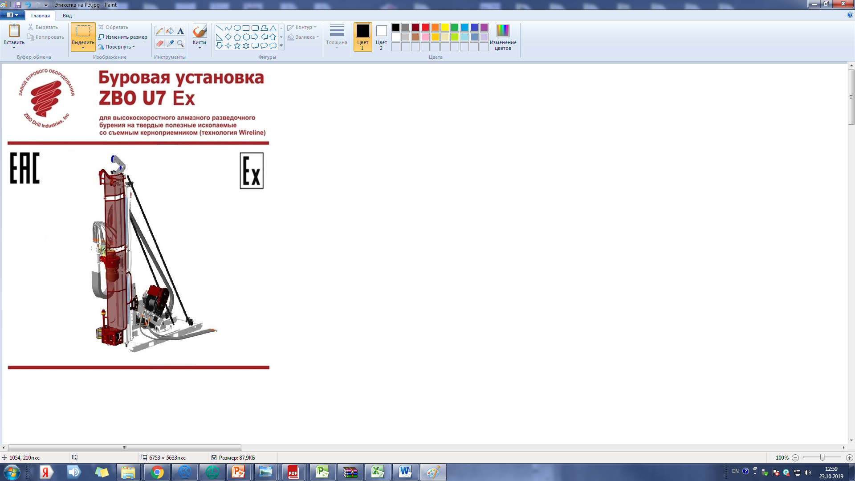

**Operating manual**

**28.92.12-028-01423045-2019 РЭ**

**ZBOU7DRILLINGRIG**

Ed. 11.2019

**Orenburg 2019**

**Our partners in Russia and CIS**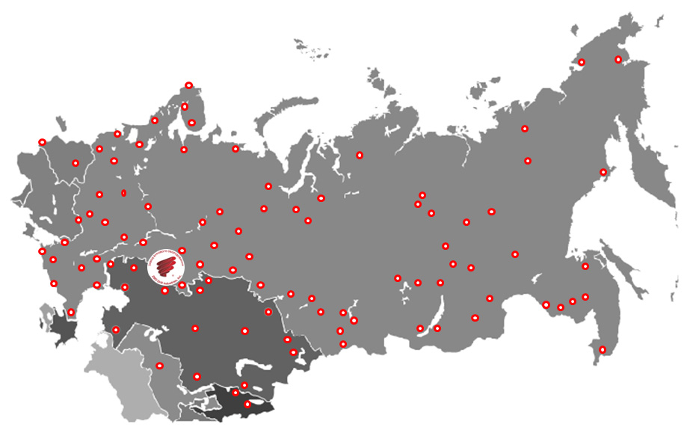

**Today, more than 870 companies are using the products of ZBO Drill Industries, Inc.**



# Introduction

The operational manual contains the instructions on the procedures of start-up, stall and drilling, additional instructions, provided by the operator diagrams of technical service of ZBO U7 DRILLING RIG, produced by Open joint-stock company ZBO Drill Industry, Inc. (hereinafter – ZBO Drill Industry, Inc.).

Specialists of ZBO Drill Industry, Inc. can provide any detailed data on technical service for ZBO U7 DRILLING RIG.

Before starting operation, pay attention to all sections of the operation manual.

All copyrights reserved. The owner of the equipment acquires the right for using the following documentation only for internal use. ZBO Drill Industries, Inc. reserves the right to change the design to improve the operation characteristics without notice. The data provided in the present document are considered as exact at the time of their publication but they can change both for the elimination of the found discrepancies, and due to tracking of changes in products.

The present operation manual is created for the company's engineering personnel responsible for repair and drilling works as well as for the tool pushers, drilling rig operators and their assistants.

Table of contents

Introduction 2

1. General instructions 5

2. Technical characteristics 6

2.1. Dementions and weight 6

2.2. Structure of the rig 8

2.3. Operating characteristics: 13

2.4 Labelling 16

3. Preparation of the rig for drilling 19

3.1. Pre-start operations 19

3.2. Moving the feed and setting it to the specified angle 21

4. Drilling 24

4.1. Preparation for drilling 24

4.2. Regulating the flush liquid flow 25

4.3. Starting of regular feed and crown load-leveling 25

4.4. Operation with Wireline winch 28

4.5. Build-up and disassembly of the drill string 29

4.6 Failure criteria and personnel actions 31

5. Maintenance 35

5.1. General instructions 35

5.2. Service of hydraulicsystem 35

5.3. Maintenance schedule 36

5.4 Recommendation for maintenance of gas springs 40

6. Operation of hydraulic system 44

6.1. Operating principals of the hydraulic system 44

6.2. Main components of the hydraulic system 44

7. Storage 52

7.1. Preparing for short-long storage 52

7.2. Preparing for long-term storage 52

8. Transportation 56

9. Utilization 57

Appendix A 58

Appendix B 59

FOR NOTES 61

**Record of revisions** 63

# General information

ZBO U7 DRILLING RIG (hereinafter referred to as drilling rig or rig) is designed for core drilling from the surface and underground mine workings, exploration wells for solid minerals with core selection Wireline Coring (with a removable core receiver). Drilling is carried out using fluids.

Control of the drilling rig, as well as various manipulations with the drill string and lifting of the down hole tool on the rope are carried out from the control unit, the placement of which depends on the conditions of drilling operations.

The rig can be equipped with two sensors of different lengths, as well as rotators of two different sizes required to solve various tasks of drilling operations.

Type of climatic performance – O1, O2, O3 according to GOST 15150, and the rig is operated at an ambient temperature of minus 5 to plus 35ºC.

.

# Technical characteristics

## Overall dimensions and weight

**Drilling Block:**

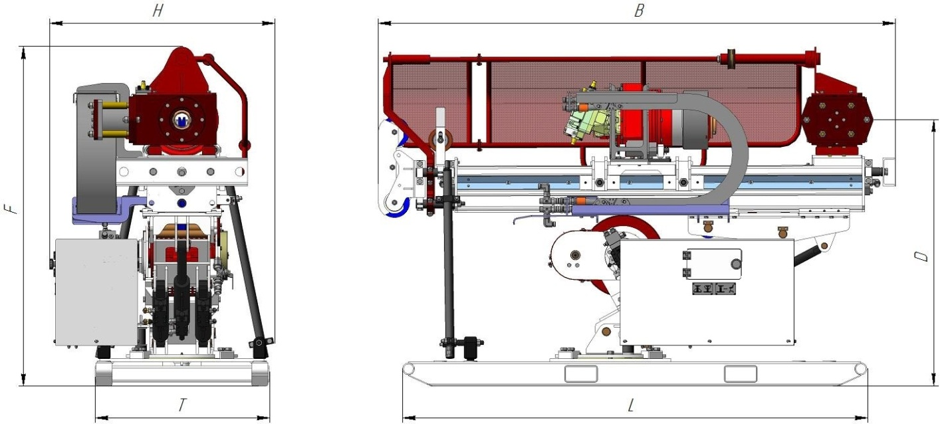

Figure 1 – Drilling Block in transit condition

Таблица 1- Overall dimensions of Drilling Block

|  |  |  |  |
| --- | --- | --- | --- |
| **Feed stroke, mm**  **Dimensions**  **and weight** | **850** | **1800** | |
| В, mm | 2590  (3540*) | 3640  (4600*) | |
| D, mm | 1330 | | |
| L, mm | 2300 | | |
| H, mm | 1105 | | |
| F, mm | 1690 | | |
| T, mm | 850 | | |
| Weight, kg | 1620 | | 1780 |

* Maximum dimensions with extended crown block and stop.

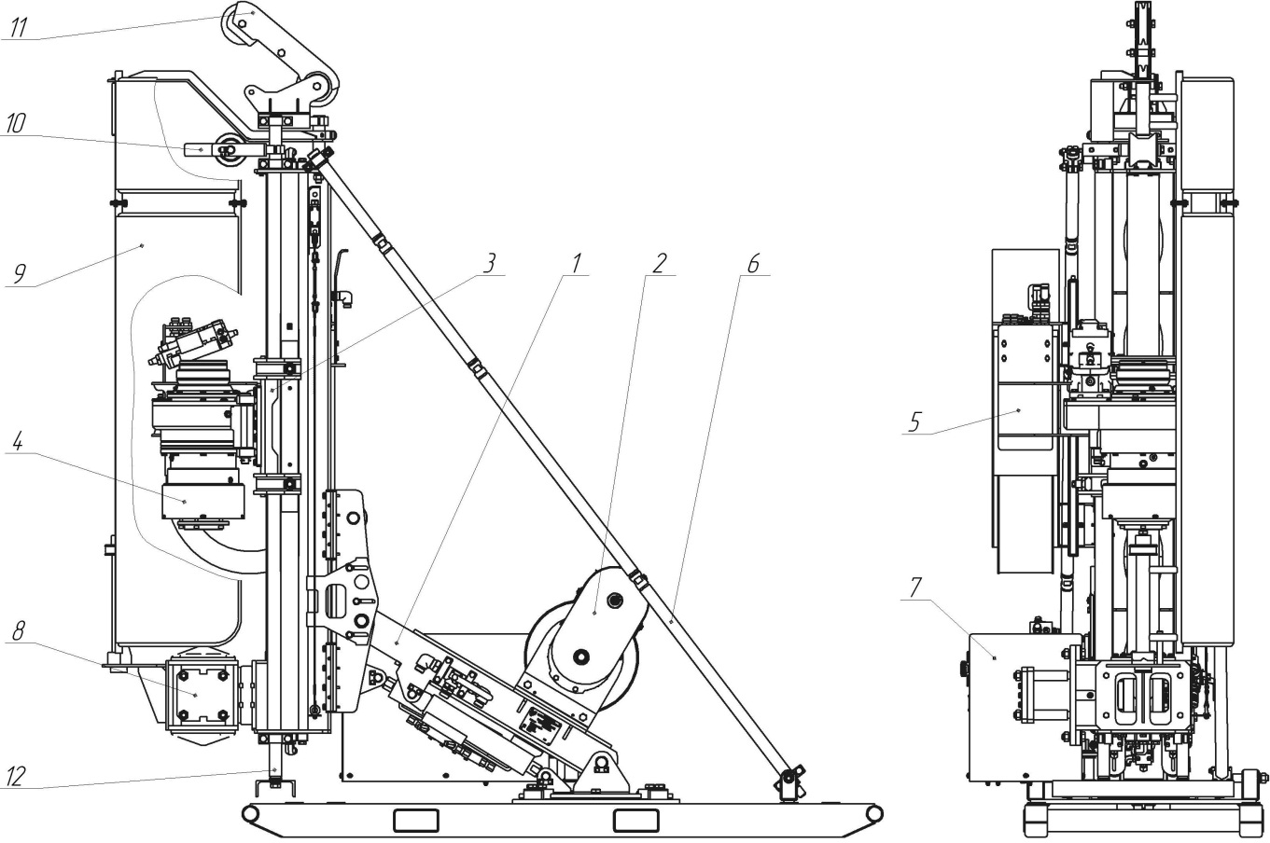

Figure 2 – Drilling Block in working position 90°

**Control block:**

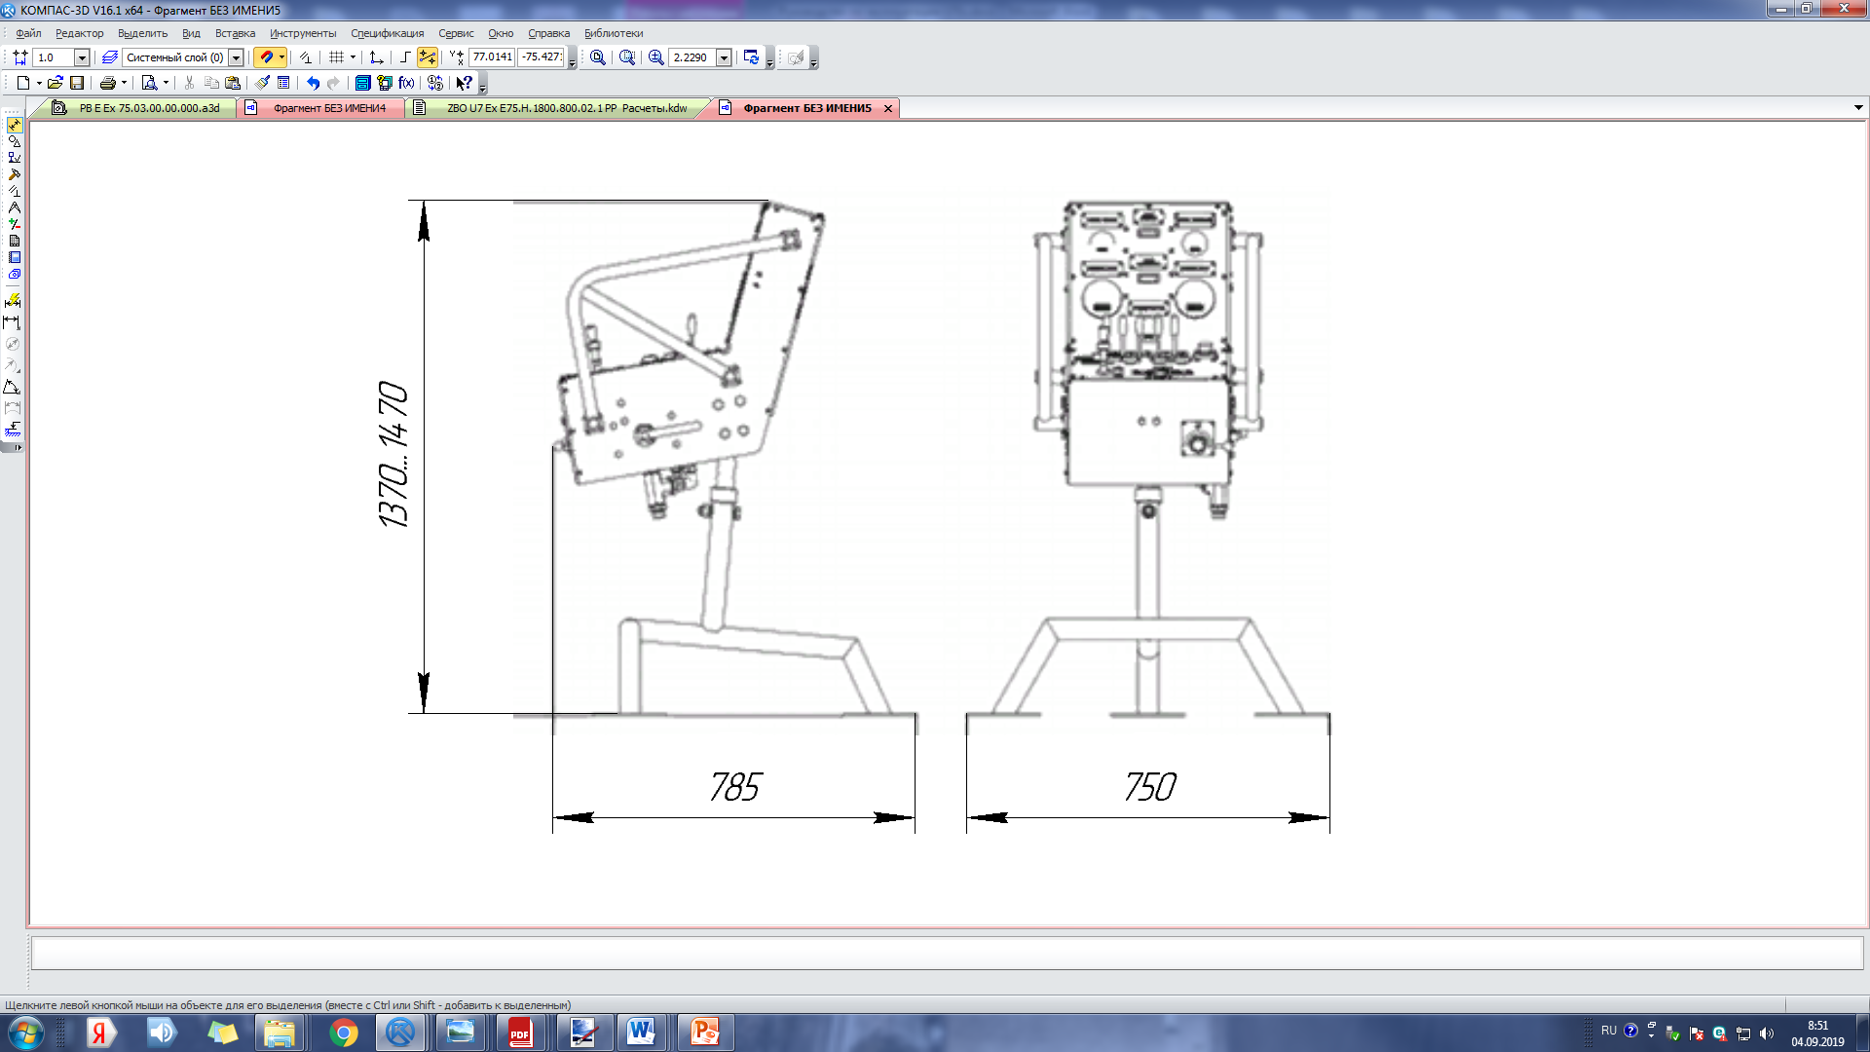

Figure 3 – Control block

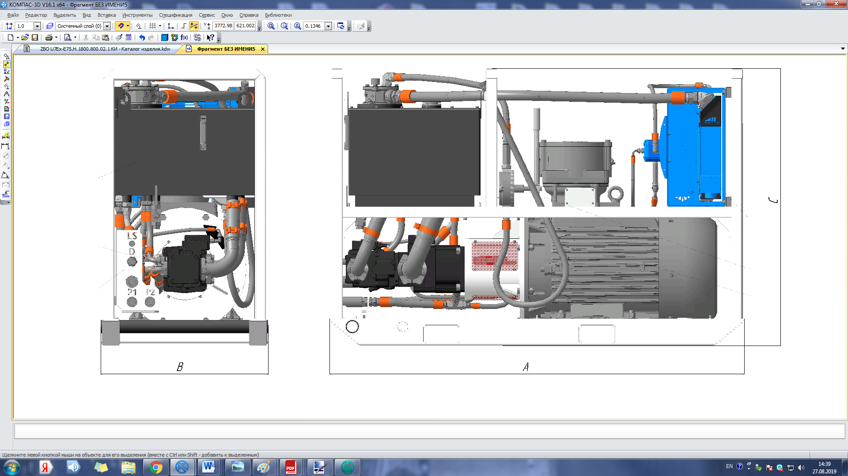

Figure 4 –Power Block

## Structure of the rig

Figures 1, 2, 3, 4 demonstrate the structure of the rig.

**Drilling Block:**

Drilling Block (Figure2) consists of the following elements:

1. The frame of drilling block;

2. Wireline winch;

3. Feeder;

4. Rotator;

5. System of Cable Holder;

6. Safety stops;

7. Hydraulic equipment box;

8. Tubing catcher;

9. Protective screen;

10. Supporting roller;

11. Kronblok;

12. Support.

**Control Block:**

The control block contains two functional zones:

- monitoring zone;

- control zone.

Monitoring zone:

1 – Feed force pressure gauge shows the pressure in the rod side of the main hydraulic cylinder. The pressure gauge has a double scale showing the feed pressure [bar] and the corresponding feed force [kN].

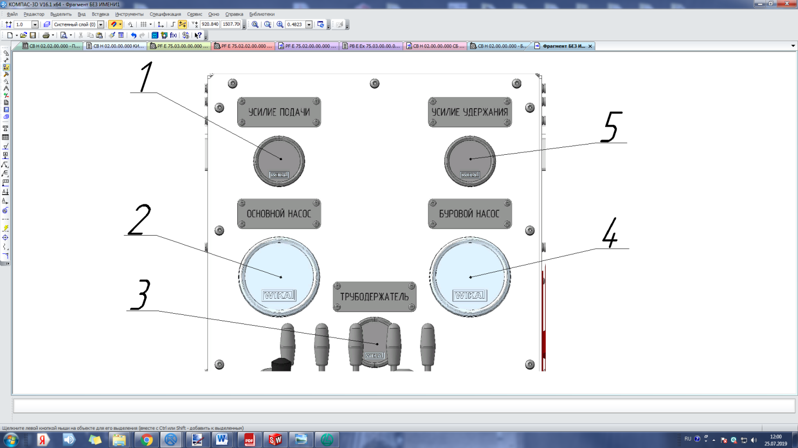

Figure 5 – Monitoring zone

2 – The main pump pressure gauge shows the pressure of the main hydraulic pump [bar].

3 – Auxiliary pump circuit pressure indicator [bar].It serves to control the charge pressure of the gas spring.

4 – The drilling mud pressure gauge shows the mud pressure in the well feed line [bar].

5 – Holding pressure gauge shows the pressure in the head end of the main hydraulic cylinder. The pressure gauge has a double scale showing the holding pressure [bar] and the corresponding holding force [kN].

Control zone:

1 – The pressure regulator of the main pump.

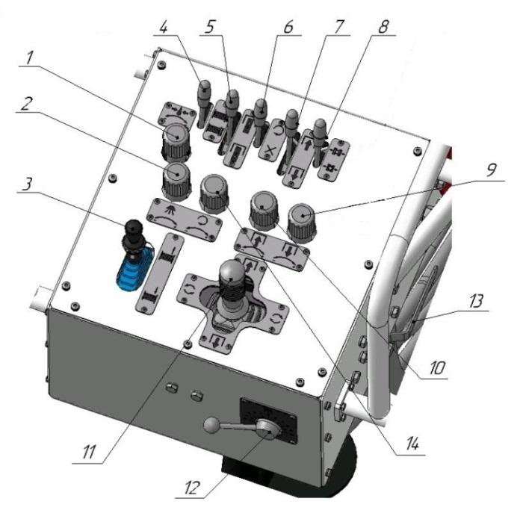2 –The flow regulator of the mud pump is in the mode of landing of head block/overshot.

Figure 6 – Control zone

3 – Joystick hydraulic single coordinate winch control Wireline core with protection against accidental movement

4 – Distributer two-position:

- «from myself» enable freewheel mode Wireline hoist

- «towards yourself» disable freewheel mode Wireline hoist

5 – Distributer three-position control drill string:

- «from myself» mode of operation for the descent of the drilling string into the well;

- «towards yourself» mode of lifting the drilling string;

- Middle position drilling mode.

6 – Distributer two-position rotation control:

- «from myself» enable rotation of the rotator;

- «towards yourself» disable rotation of the rotator.

7 – Distributer three-position control stroke:

- «from myself» – working stroke to the bottom of the well;

- «towards yourself» – working stroke from the bottom of the well;

- Middle – Stop.

8 – Distributer two-position control rod holder:

- «from myself» – enable manual mode;

- «Middle» – enable automatic mode.

9 – Holding force regulator (when drilling).

10 – Feed force regulator (when drilling).

11 – Joystick hydraulic two-coordinate control mode "screwing/unscrewing" (right/left), rapid movement of the rotator (up/down).

12 – Drilling pump flow control lever in drilling mode.

13 – Three-way valve for pressure relief in the drill string.

14 – The controller changes frequency of rotation.

**Power Block;**

Table2– Overall dimensions and weight of Power Block

|  |  |  |
| --- | --- | --- |
| **Power, kW**  **Dimensions**  **and weight** | **55** | **75** |
| В, mm | 1210 | 1380 |
| C, mm | 1660 | 1910 |
| D, mm | 750 | 840 |
| Weight, kg | 915 | 1200 |

Power Block (figure 4) consists of the following elements:

1 – Frame;

2 – Hydraulic tank;

3 – Hydraulic block;

4 – Electromotor;

5 – Oil cooler of hydraulic system;

6 – Manual pump;

## Operating characteristic:

Table 3 – Depth of core boring with the use of technological washing

|  |  |  |
| --- | --- | --- |
| Pipe size, mm | Rotator N, m | Rotator Н, m |
| 44,8 (А) | 1315 |  |
| 55,6 (В) | 795 | 795 |
| 69,9 (N) | 645 | 645 |
| 88,9 (Н) |  | 440 |

Note - given the drilling depth, are estimated and refer to vertical down drilling in homogeneous soil with the use of fluids.

Drilling angle, deg from-90to+90

Drilling block

|  |  |
| --- | --- |
| Feed stroke, m | 0,85-1,8 |
| Feed speed, m/s | 0,8…1 |
| Feed force down, kN  Feed force up, kN | 65  65 |

Rotator:

|  |  |  |
| --- | --- | --- |
| Drive | reversible hydraulic motor with variable speed | |
| Reduction gear | Helical gear with work in oil bath |

Table 4 - Technical characteristics of Rotators

|  |  |  |
| --- | --- | --- |
| Parameter | Rotator N | Rotator H |
| Max Rotation Frequency, rpm | 800 | 800 |
| Max Torque, N·m | 1300 | 1570 |
| Drill Rod Size, mm | 44,8 – 69,9  (A – N) | 55,6 – 88,9  (B – H) |

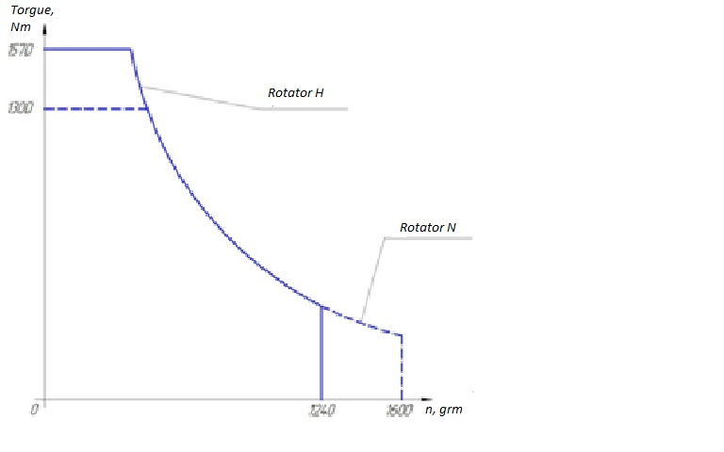

Figure 7 - Diagram of dependence of torque on drive rod speed

|  |  |
| --- | --- |
| Collet | opened by hydraulics |
|  | with spring closure |
| Drift diameter of the collet, mm | 100 |
| Holding capacity, kN | 120 |

Tubing catcher:

|  |  |
| --- | --- |
| Type | Hydraulic opening,  normally closed by means of a gas spring synchronized with the rotator cartridge; |
|  |  |
| Drift diameter, mm | 102 |
| Holding capacity, kN | 112,5 |

|  |  |
| --- | --- |
|  |  |

WireLine winch:

Load capacity (empty/full tank), kN 11,07/4,02

Speed (empty/full tank), m/min 122,5/337,2

Cable capacity of the tank, m 800

Cable diameter, mm 4,8

## 2.4 Labelling

The drilling rig uses safety signs to prevent accidents, reduce injuries and occupational diseases, eliminate danger to life, harm to human health, the risk of fires or accidents.

Table 5 - Safety signs used on drilling rig U7.

|  |  |  |  |
| --- | --- | --- | --- |
| Code  of sign | Color image | Semantic  meaning | Placement |
| 1 | 2 | 3 | 4 |
| Р06 | Описание: ГОСТ 12.4.026-2015 Система стандартов безопасности труда (ССБТ). Цвета сигнальные, знаки безопасности и разметка сигнальная. Назначение и правила применения. Общие технические требования и характеристики. Методы испытаний (с Поправками) | Access by unauthorized persons is prohibited | Control block |
| Р17 | Описание: ГОСТ 12.4.026-2015 Система стандартов безопасности труда (ССБТ). Цвета сигнальные, знаки безопасности и разметка сигнальная. Назначение и правила применения. Общие технические требования и характеристики. Методы испытаний (с Поправками) | Do not spray water | Control block |
| W25 | Описание: ГОСТ 12.4.026-2015 Система стандартов безопасности труда (ССБТ). Цвета сигнальные, знаки безопасности и разметка сигнальная. Назначение и правила применения. Общие технические требования и характеристики. Методы испытаний (с Поправками) | Attention. Equipment switching on automatically | Oil cooler of hydraulic system |
| W26 | Описание: ГОСТ 12.4.026-2015 Система стандартов безопасности труда (ССБТ). Цвета сигнальные, знаки безопасности и разметка сигнальная. Назначение и правила применения. Общие технические требования и характеристики. Методы испытаний (с Поправками) | Carefully. Hot surface | Rotator, oil cooler of the hydraulic system, oil tank |
| W27 | Описание: ГОСТ 12.4.026-2015 Система стандартов безопасности труда (ССБТ). Цвета сигнальные, знаки безопасности и разметка сигнальная. Назначение и правила применения. Общие технические требования и характеристики. Методы испытаний (с Поправками) | Carefully. Possible hand injury | Rotator, frame, WireLine winch, tubing catcher |
| W29 | Описание: ГОСТ 12.4.026-2015 Система стандартов безопасности труда (ССБТ). Цвета сигнальные, знаки безопасности и разметка сигнальная. Назначение и правила применения. Общие технические требования и характеристики. Методы испытаний (с Поправками) | Carefully. Tightening between rotating elements is possible | Rotator, main winch, WireLine winch, oil cooler of the hydraulic system |
| М01 | Описание: ГОСТ 12.4.026-2015 Система стандартов безопасности труда (ССБТ). Цвета сигнальные, знаки безопасности и разметка сигнальная. Назначение и правила применения. Общие технические требования и характеристики. Методы испытаний (с Поправками) | Work with safety glasses | Control block |
| М02 | Описание: ГОСТ 12.4.026-2015 Система стандартов безопасности труда (ССБТ). Цвета сигнальные, знаки безопасности и разметка сигнальная. Назначение и правила применения. Общие технические требования и характеристики. Методы испытаний (с Поправками) | Work in a protective helmet | Control block |
| М03 | Описание: ГОСТ 12.4.026-2015 Система стандартов безопасности труда (ССБТ). Цвета сигнальные, знаки безопасности и разметка сигнальная. Назначение и правила применения. Общие технические требования и характеристики. Методы испытаний (с Поправками) | Work in protective headphones | Control block |
| М05 | Описание: ГОСТ 12.4.026-2015 Система стандартов безопасности труда (ССБТ). Цвета сигнальные, знаки безопасности и разметка сигнальная. Назначение и правила применения. Общие технические требования и характеристики. Методы испытаний (с Поправками) | Work in protective shoes | Control block |
| М06 | Описание: ГОСТ 12.4.026-2015 Система стандартов безопасности труда (ССБТ). Цвета сигнальные, знаки безопасности и разметка сигнальная. Назначение и правила применения. Общие технические требования и характеристики. Методы испытаний (с Поправками) | Work in protective gloves | Control block |
| М07 | Описание: ГОСТ 12.4.026-2015 Система стандартов безопасности труда (ССБТ). Цвета сигнальные, знаки безопасности и разметка сигнальная. Назначение и правила применения. Общие технические требования и характеристики. Методы испытаний (с Поправками) | Work in protective clothing | Control block |

Table 6- Symbols used on the drilling rig U7.

|  |  |  |  |
| --- | --- | --- | --- |
| Number  of symbol | Symbol | Value/application | Placement |
| 01 |  | Hydraulic system | Hydraulic tank |
| 03 |  | Read the operator's manual | Control block |

# Preparation for drilling

## Pre-start operations

After delivery of the Drilling rig to the place of work first of all it is necessary to fix the Drilling block according to the anchoring scheme see figure 8

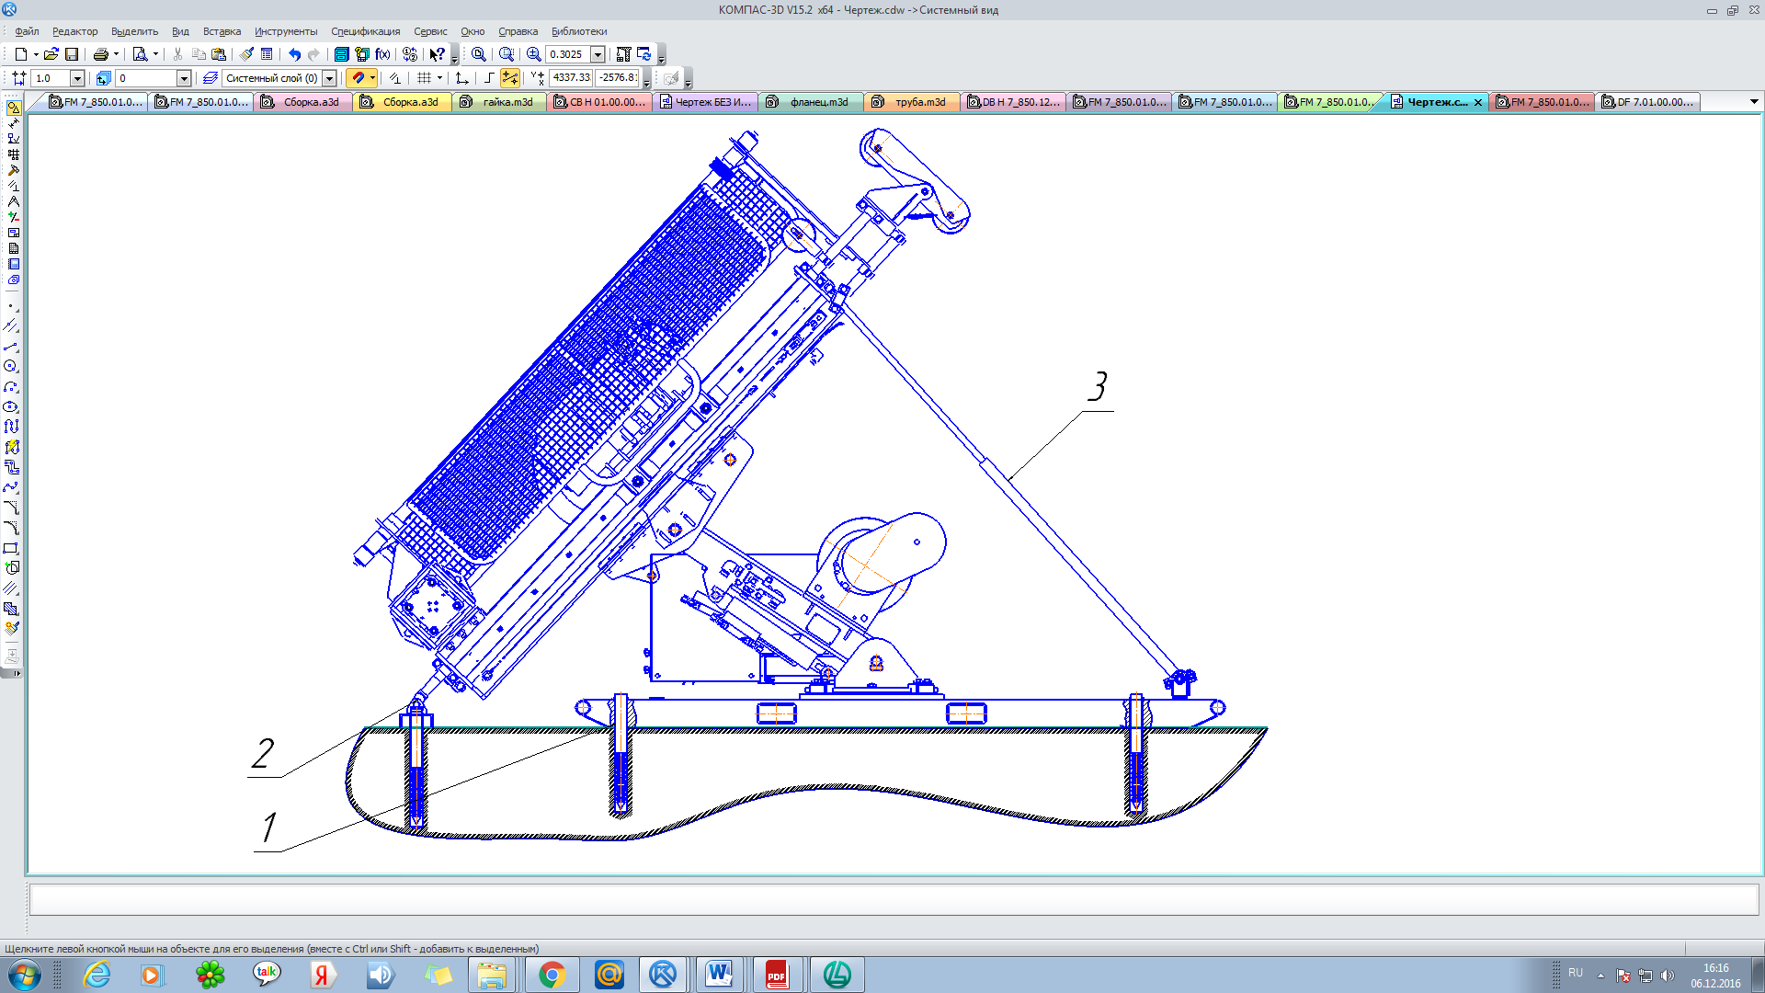

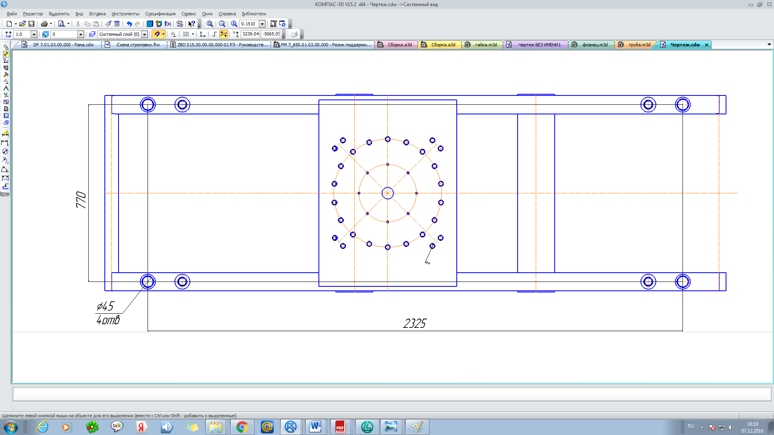

Places for anchors

Figure8–the anchoring scheme

Secure the frame of the drilling block to the mine floor or platform using anchor or expansion bolts 1 (4 pieces).

**ATENTION: a place of PRODUCTION WHERE you plan to set a DRILLing block SHOULD HAVE a SMOOTH, SOLID AREA, WHICH AREA MUST BE GUARANTEED to be larger than the area of the BASE FRAME.**

The Hydraulic System must be assembled according to the Hydraulic Scheme. Editing of sleeves is high pressure produced on marking in obedience to the chart of connecting.

Check tightening hoses

Check the electrical supply, make sure there is no damage to the input cable, fixing the cables in the cable glands.

Check the oil level in the hydraulic tank. If the oil level in the tank is low, the start of the power plant will be possible only after the restoration of the minimum permissible level.

Check the oil level in the Rotator. If the level is low, top up the oil.

**ATTENTION: BEFORE REFILLING, THOROUGHLY CLEAN THE AREA AROUND THE HAND PUMP FILLING SLEEVE. USE ONLY CLEAN, UNPOLLUTED CONTAINERS FOR REFILLING. IT IS FORBIDDEN TO USE CONTAINERS IN WHICH FOREIGN LIQUIDS WERE STORED.**

**ATTENTION: WHEN DISMANTLING AND TRANSPORTING THE DRILLING RIG IN CASE OF DISCONNECTION OF HYDRAULIC HOSES, NOT EQUIPPED WITH QUICK COUPLINGS, THEIR ENDS MUST BE CLOSED WITH PLUGS TO PREVENT THE INGRESS OF DUST, DIRT AND OTHER PARTICLES OR OBJECTS, WHICH CAN NEGATIVELY AFFECT THEIR WORK.**

During the inspection, make sure that there are no loose or damaged components, leaks or malfunctions on the unit, if they are detected, it is necessary to carry out appropriate repairs before starting the unit.

Inspect the mud supply hose, check for damage, if found, the hose must be replaced.

Make sure that all control levers are in the neutral position.

The drilling pump flow control lever (if equipped) must be set to disable mode.

Make sure there is nobody in danger areas.

## Moving the feed and setting it to the specified angle

**Attention: TO MOVE THE FEEDER AND SET TO A SPECIFIED ANGLE WITHOUT ANCRENE FRAME OF DRILLING BLOCK IN THE FLOOR OF THE MINE IS PROHIBITED.**

**IT IS FORBIDDEN TO OPERATE THE DRILLING RIG WITHOUT INSTALLATION OF SAFETY STOPS.**

**IT IS FORBIDDEN TO BE IN THE SPACE UNDER THE CARRIAGE DURING THE LIFTING AND LOWERING OF THE FEED.**

Before starting to move the feed, it is necessary to move the handle 2 of the hydraulic equipment “see Figure 10” drawer from position «orientations» in the mode «control panel».

Move the joystick (12) “see Figure 6” and place the upper carriage (1) exactly in the center of the lower feed carriage (2). Release the three mounting screws (5) "see Figure 9" and install the plug (4) as shown “see Figure 10”. Tighten the plug mounting screws (4), loosen the sensor mounting screws to the bottom carriage (position 3, 16 pieces, M16) “see Figure 9” this is necessary to move the feed frame.

Slide the feeder using the feed handle (9) by turning "see Figure 6" the position controls (10) and (11). When the feeder reaches the desired position, tighten all clamping screws securely. Move the plug back to its original position.

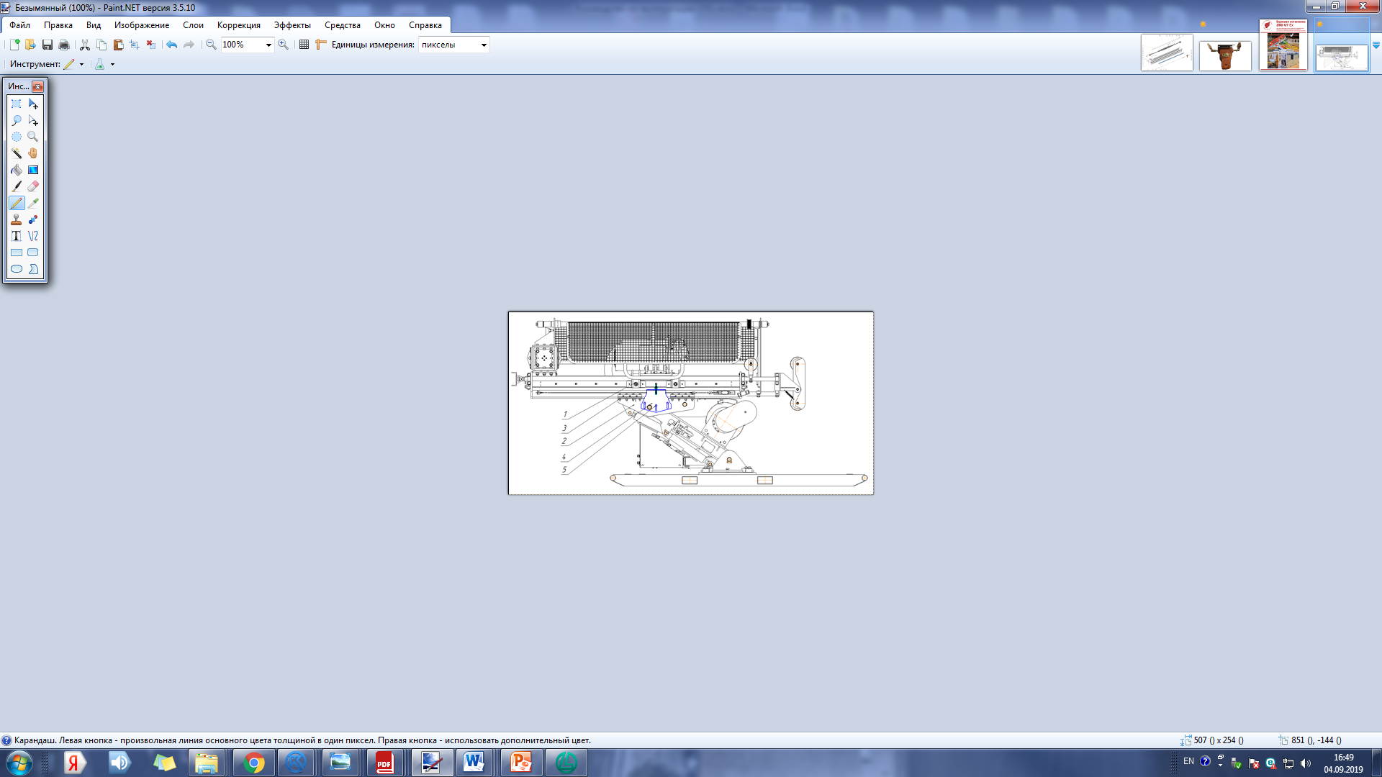

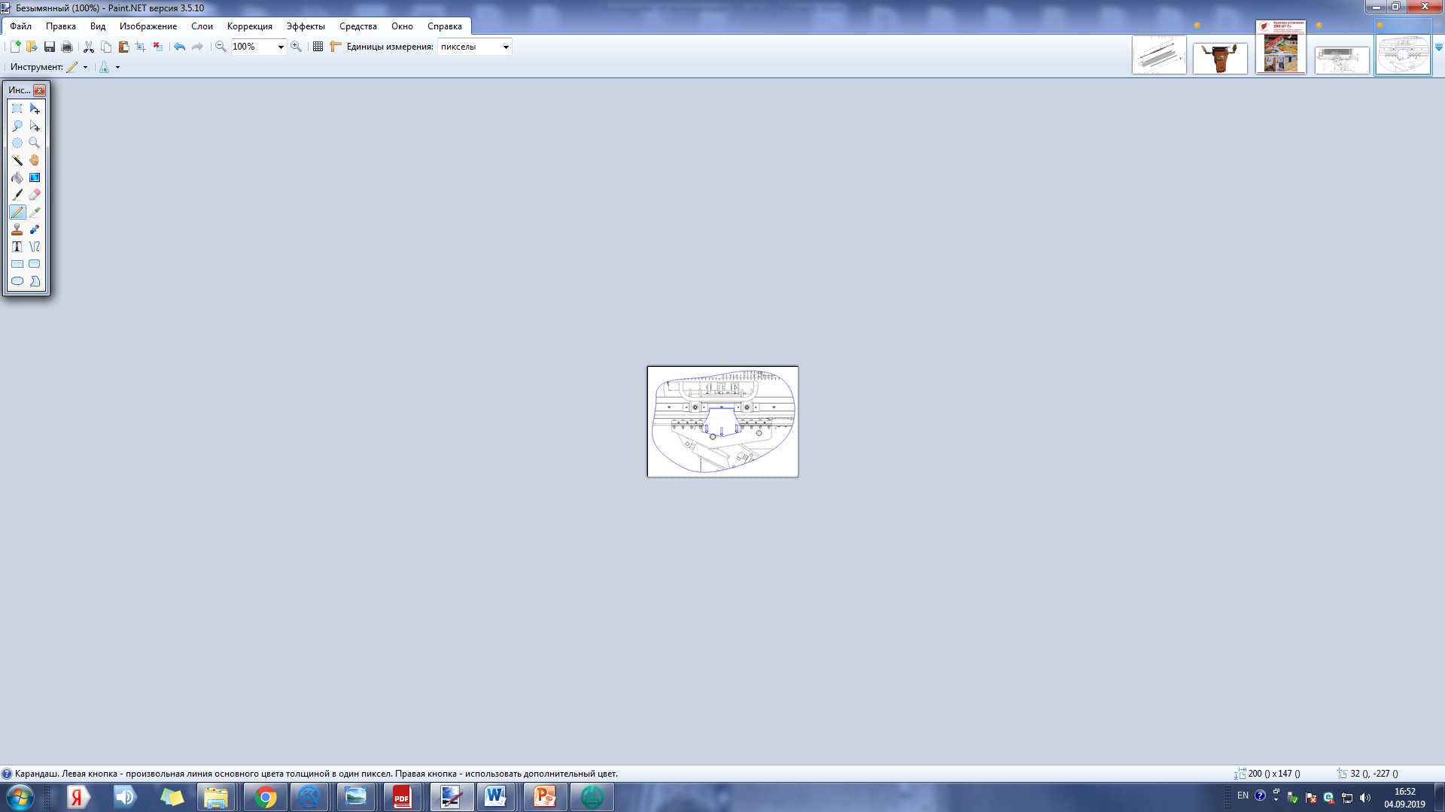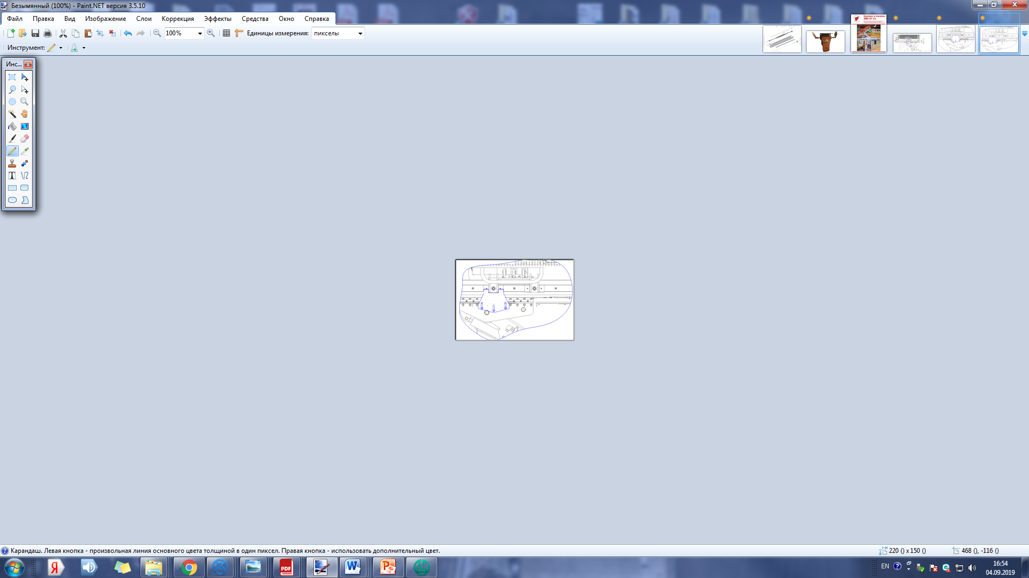

Figure 9 – Move stroke

When drilling +90 degrees, move the Feeder to the right on the stroke of the main hydraulic cylinder.

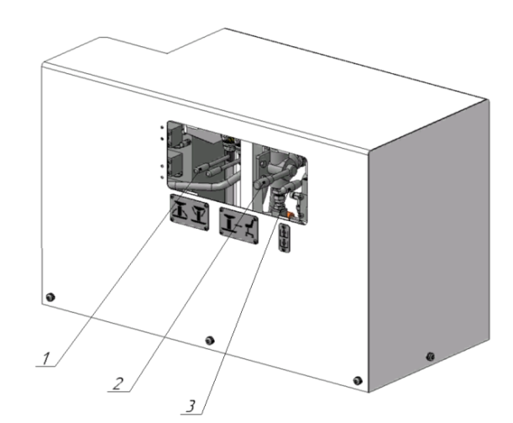

Figure 10 - Hydraulic equipment box.

Switch the control lever located in the hydraulic equipment box to the positioning mode using lever 2 and set the feeder to the specified drilling angle see Figure 10 using levers 1 see Figure 10.

**Next, you need to install the safety stops 3 (see Figure 8) and securely fix them (the length of the stops is selected based on the drilling angle). Fix the stop 2 (see Figure 8) with 1 or 2 anchors.**

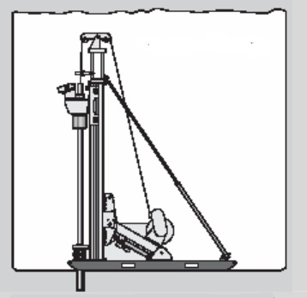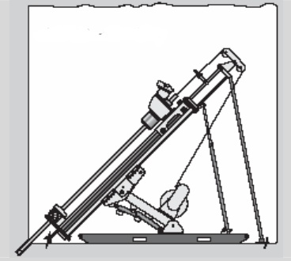

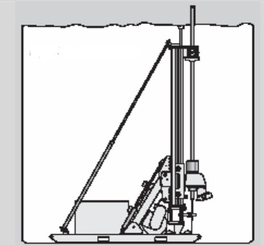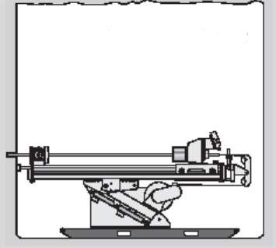

Figure 11 – Setting the feed to a specified angle

# 

# Drilling

## Preparation for drilling

**ATTENTION! BEFORE STARTING WORK, IT IS NECESSARY TO WARM UP THE HYDRAULIC OIL TO AN OPERATING TEMPERATURE OF 30-40°C.**

Drilling tools (drill pipes, the core set of drill bits, etc.) should be of the desired size and quality, corresponding to the prevailing rocks, which will be drilled.

The rig must be securely installed, aligned, but the mast should be installed at the required drilling angle.

**ATTENTION! IT IS FORBIDDEN TO WORK AT THE REMOVED COVERS AND PROTECTIONS!**

Make sure there is drilling fluid. Make sure the mud pump suction hose is in good condition and the strainer is clean and unclogged (hose and strainer are optional).

Start-up and regulation of the flow of the washing liquid is carried out from the control panel.

**ATTENTION! IT IS NECESSARY TO DO VISUALLY CONTROLLING THE PRESENCE OF WATER SUPPLY.**

Start the motor.

It is recommended to check the pressure of the gas spring of the rod holder once a month, at the moment when the rods begin to slip through the rod holder or before the start of the up drilling.

If the rod begins to slip in the pipe holder, the reason for this may be worn clamping Cams, low pressure in the gas spring. It is recommended to check the presence of grease in the area of operation of the Cams in contact with the body and lubricate if necessary.

**ATTENTION! WORKING IN AREAS WITH HIGH NOISE LEVELS, IT IS NECESSARY TO APPLY PERSONAL PROTECTIVE EQUIPMENT ACCORDING TO GOST 12.4.051.**

Note: During the operation of the rig, the noise level is high.

## Regulating the flush liquid flow

Start-up and performance of the drilling pump are carried out from the main control panel of the rig by turning the regulator of the washing pump.

The Pressure of the drilling pump is displayed on the pressure gauge of the drilling fluid.

Control drilling fluid flow visually from the wellhead or the top of the casing pipe.

## Starting of the regular feed and crown load-leveling

Check the recommended load on the crown according to the user manual of the manufacturer of drill bits.

Start drilling

If drilling is done with a casing of size H, use a short section (600 mm) of casing P clamped by the rod holder as the centralizer.

If drilling is done with a casing of size H, use a short section (600 mm) of casing P clamped by the pipe holder as the centralizer.

Make sure that the top section of the casing used as the centralizer is level with the top edge of the pipe holder and does not interfere with the move of the rotator. After the well has been drilled, the casing guide can be removed.

Start drilling the Casing slowly to avoid any deviation from the axis of the well.

The casing Shoe should be planted in dense rocks before proceeding to drilling with Wireline.

Compile and configure the Head Assembly according to the operating manual.

Screw the flushing oil seal-swivel on the Head Assembly set with the core receiver installed. Slowly move Wireline winch control lever to raise the Head Assembly set above the rotator.

Chuck rotator is in the decompressed position, to establish a core set, you must move the control lever tube holder mode "unclench", lower core-set in the well casing, coring clamp set in the tube holder by moving the lever in the position "clamped".

**ATTENTION! WHEN THE ROTATION OF THE ROTATOR IS TURNED ON, THE ROTATOR CARTRIDGE IS CLAMPED AUTOMATICALLY, AND THE PIPE HOLDER IS UNCLENCHED.**

For ease of operation on inclined wells, use a support roller, which is located at the top of feed.

"Weighing rods" when drilling wells with an angle of inclination -90° or close to them:

Make sure the feed force regulator position 10, see Figure 6 is fully unscrewed (left direction of rotation), and monitor the pressure gauge position 1 see Figure 5.

Before drilling, it is necessary to make a "weighing", it is necessary to compensate weight of the drill string to ensure the correct values of the feed force.

The rotator Chuck is clamped automatically, and the rod holder is unclenched when the rotation is switched on. To start weighing the rods, you must first turn on the rotation of the distributor position 6 see Figure 6. Turn the effort regulator to the holding position 9 see Figure 6 for a few turns clockwise. The holding force is controlled by the pressure gauge position 6 see Figure 5 on the control panel. Turn on the working feed of the drilling tool using the feed lever see Figure 6 position 7.

Use the hold force control position 9 see Figure 6 to hold the upper carriage in place, preventing it from moving up or down. Now the "Weighing" is done».

Start drilling

Turn on drilling mud flushing position 13 see Figure 6, then lever 6 see Figure 6 to turn on the rotation, turn lever 7 see Figure 6 "working feed" to the working movement mode down, the feed force should be zero. Control on the pressure gauge the "feed Force" 1 see Figure 5 by smoothly turning the regulator 10 see Figure 6.

Use the feed force handle for slowly increase the load on the drill bit until the drill string reaches the bottom of the well. To increase the speed, use the speed controller 14 see Figure 6, control the pressure on the main pump with the pressure gauge 2 see Figure 5 using the regulator 1 see Figure 6.

Continue to increase the feed force to achieve the desired drilling speed, taking into account the maximum allowable load of the Drilling Bit used, as well as on the pressure gauge "feed Force". Continue drilling until the end of the rotator stroke or until the inner core pipe is filled.

The end of the drilling

Stop the rotator feed by moving the lever see Figure 6 position 7 to the neutral position.

Stop rotation by moving the lever see Figure 6 position 6 to the neutral position.

After drilling is stopped, it is recommended to rinse the well within a few minutes to avoid problems associated with blockage of the core pipe with sludge.

## Operation with Wireline winch

Free rotation of the Wireline winch

To lower the overshot, use the free rotation of the Wireline winch drum.

To unlock the winch drum, move the winch stroke control handle see Figure 6 position 4 away from you from the neutral position.

In the free position of the winch drum and the rope is unwound under the own weight of the overshot lowered into the well or under the pressure of water pumped into the well.

After the overshot reaches the head unit the lever position 4 see Figure 6 must be moved to the neutral position.

Controlled Wireline winch lowering

For the winch drum using the hydraulic motor, slowly press the winch direction control handle position 3 see Figure 6 forward (away from yourself), the drum will start to rotate.

To increase the speed of the rope, increase the angle of the handle position 3 see Figure 6.

When you release the handle under the action of the spring will return to the neutral position.

Controlled Wireline winch rise

To winding the rope on the winch drum under the action of the hydraulic motor, push the winch direction control knob position 3 see Figure 6 up and pull slowly towards you. The drum will start spinning.

To increase the lifting speed of the rope, increase the angle of the handle position 3 see Figure 6.

When you release the handle under the action of the spring will return to the neutral position.

## Drill string connection and break down

Drill string connection

Carefully feed the next drill pipe and align with the end of the last drilled pipe. Screw "by hand" a few turns of thread. For convenience, use the centralizer. Make sure the pipe holder is clamped. Lift the rotator above the folding plane.

To screw the rod move the joystick knob position 11 see Figure 6 to the right! The cartridge will close (the pipe holder remains in the clamped position) and the rotator will start turning clockwise. At the same time, the cylinder of the hydraulic feed mechanism is disengaged, so that the twisting of the rods can be performed without damaging the thread.

During docking, it is important to limit the force applied torque, otherwise there may be difficulties with the subsequent unscrewing of the rods:

– When feeding the rod into the well, set the system pressure regulator position 1 Figure 6 by controlling the pressure gauge position 2 see Figure 5 at 80-100 bar. This will limit the torque.

- The rotation of the clamping Chuck in the process of connection device should be carried out slowly with a maximum speed of approximately 250-300 rpm. High rotation speed is the cause of high load on the connection from the inertial torque during landing.

Disassembly of the drill string

Lift the drill string up with the rotator so that the plane of the drill pipe connector is above the upper point of the rotator when it is in the lowest position.

To unscrew the rod increase the regulator position 1 see Figure 6 controlling the pressure gauge position 2 see Figure 5 move the joystick handle position 11 to the left! The cartridge will close (the rod holder remains in the clamped position) and the rotator will start to turn counterclockwise. At the same time, the cylinder of the hydraulic feed mechanism is disengaged, as a result of which the unscrewing of the rods can be performed without damaging the thread.

When screwing / unscrewing the rods, you need to consider the direction of drilling -90 or +90 deg, lever position 7 see Figure 6. When drilling up (+90), the lever must be switched to the up position, this will compensate for the weight of the rotator when screwing/unscrewing.

## 4.6 Failure criteria and personnel actions

Table 4 – Criteria for refusals and possible actions of personnel

|  |  |  |
| --- | --- | --- |
| Type | Reason | Action |
| 1 | 2 | 3 |
| Deformation of metal structures elements | Exceeding the permissible load | - Restore the geometry of deformed elements to the limits of the established permissible values  - Replace the bent items on new metal structures |
| Deformation of elements fasteners | Exceeding the permissible load | Replace deformed fasteners with new ones |
| The weakening of support clips | Vibration impact | Tighten support clips  Use threaded sealants (for approval by the manufacturer) |
| Cracks in welds and in the weld proximity | Exceeding the permissible load | Remove mechanically the welds with the detected defects, apply new welds |
| Vibration impact |
| Cracks in the base metal | Exceeding the permissible load | Replace the damaged elements of the mast for the new |
| Vibration impact |
| Local mechanical damage (breaks, cuts, fractures) of the base metal | Exceeding the permissible load,  mechanical impact | Replace the damaged elements of the mast for the new |

|  |  |  |
| --- | --- | --- |
| 1 | 2 | 3 |
| The stratification of the base metal | The mismatch of metal | Replace inappropriate elements of the mast for the new |
| Corrosion damage | Corrosion protection defects | Clean the base metal from rust, apply corrosion protection |
| Fluid leakage | Connection depressurization | Tighten the connecting elements |
| The wear on the sealing element | Replace connecting and (or) sealing elements |
| Slip of the drill rods in the Rotator Chuck | Cams abrasion | Replace Cams |
| Failure of springs | Replace springs |
| Oil leak from the upper oil seal of the rotator (when drilling +90°) | Cuff abrasion  Ring cuff abrasion | replace Cuff  replace Ring cuff |
| No indication of drilling mud pressure gauge | Violation of the integrity of the media separator membrane | Media separator membrane replacement |
|  | The presence of air in the sleeve of the drilling mud pressure gauge | Fill hydraulic oil system separator medium – pressure gauge without the presence of air bubbles |
| Engine does not start | There is no voltage in the electrical system | See above |
|  | Stop/emergency buttons pressed or faulty | Check operability of stop/emergency buttons |
| Failure of the rope stacker Wireline winch | Rollers abrasion | Replace the rollers |
| Flag abrasion | Lubrication lack  Replace the flag |

Table 5 - Criteria for the limit states of the product elements

|  |  |  |
| --- | --- | --- |
| Product node | Name of indicator | Limit value |
| 1 | 2 | 3 |
| The nodes of the Drilling Block, Power Block, Control Block, Braces  Pipes  Frame | Deviations of the form of the main elements of metal structures | − reducing the thickness of the elements due to corrosion by more than 10 % of the original thickness  − the presence of local deformations in the elements:  • on the walls of pipes – more than one dent with a depth of more than three wall thicknesses, a width of more than a quarter of the diameter and a length of more than half the diameter per 1 linear meter;  • on shelves of corners – more than one dent depth of more than two thicknesses of a shelf of a corner, width more than a half of width of a shelf of a corner and length more than two widths of a shelf of a corner on 1 linear meter |
| Hydraulic cylinder | External leaks | The values exceed those specified in the standard technical documentation for the cylinder of a particular size |
| The attachments of the hydraulic cylinder | Cracks of any size and arrangement |
| Cylinder rod | Ultimate bending or local detachment of the hardened layer; |
| The working surface of cylinder or rod | Limit wear and tear, scuffing |
| Hydraulic cylinder parts | breakdowns requiring disassembly of the hydraulic cylinder and replacement of parts |

|  |  |  |
| --- | --- | --- |
| 1 | 2 | 3 |
| Shields, fences | The condition of the walls | Solid corrosion |
| Finger joints;  flange connection | The status of the surface form deviation | Cracks of any size and arrangement |
|  |  | Wear of seating surfaces |
|  |  | Curves, visible when viewed |

# Maintenance

## General instructions

The performance and reliability of the rig depend to a large extent on timely maintenance. Regular monitoring of the technical condition and timely troubleshooting prevents interruptions and downtime of the installation.

The most common cause of damage to the hydraulic system - contamination of hydraulic oil, in this regard:

- Always keep clean and avoid contamination of the rig. Faults and oil leaks are much easier to detect on clean equipment;

- Do not leave the components of the hydraulic system open or exposed to external influences;

- Always protect the disconnected ends of the hoses and connection plugs;

- Pump oil into the hydraulic tank with a manual pump or fill in through the filler neck of the tank;

- Store oil only in sealed containers.

## Service of hydraulic system

Hydraulic oil should be replaced after every 2000 operating hours under normal conditions, but at least once a year.

Use only Shell Tellus S2 V46 oil or its analogues with the approval of ZBO Drill Industry, Inc.

If the quality of the oil for any reason has decreased, for example, due to high temperatures and blockages, it should be replaced as soon as possible. In such cases, the entire tank should be thoroughly rinsed from the inside.

Open the drain valve located under the tank and drain the oil completely.

Using a manual pump, pour fresh oil (100 l). When injected, the oil passes through the drain filter, preventing impurities from entering the tank.

## Maintenance schedule

Before all kinds of technical service, the equipment must be cleaned of dirt.

Oilseeds, as well as surfaces located next to the lubricated elements, must be cleaned before performing lubrication operations.

Collection and recycling of spent working fluid of a hydraulic system are made according to the requirements of the normative documents.

A drain valve is used to drain water condensate from the tank. Condensate can be collected at the bottom of the tank. The formation of condensate depends on the humidity and the number of operating cycles of the installation with its heating and cooling of the hydraulic system.

The oil level must always be kept visible in the sight glass.

**forbid! DO NOT OPERATE IF THE OIL LEVEL IS BELOW THE MINIMUM LEVEL, IT MAY CAUSE DAMAGE TO THE HYDRAULIC PUMPS.**

The service life of hydraulic oil is reduced at high temperatures.

The types of maintenance and their frequency are indicated in table 6

Table 6 – Periodicity of technical service

|  |  |
| --- | --- |
| Type of maintenance | Periodicity |
| Shift maintenance | At the beginning of the shift (every 10 hours) |
| Maintenance No.1 | Every 250 hours. |
| Maintenance No.2 | Every 500 hours. |
| Maintenance No.3 | Every 2000 hours. |
| Maintenance work | Every 8000 hours. |

Maintenance of the electric motor, hydraulic pumps, hydraulic motors, air – oil heat exchanger, hydraulic cylinders, hydraulic valves and pressure gauges to make according to their instruction manual.

The content of works on each of maintenance is presented in tables 7, 8, 9, 10, 11, 12.

Table 7 – Scope of Maintenance

|  |  |  |
| --- | --- | --- |
| Job content | Requirements | Notes |
| 1 | 2 | 3 |
| 1. Conduct an external examination. Repair detected faults | No damage to components, parts, and fasteners, as well as their tightening |  |
| 1. Check the fluid level in the tank of the hydraulic system | The level should be visible in the oil gauge window |  |
| 1. Check the oil level in the rotator | The level should be within normal limits |  |
| 1. Checking the spring of the rod holder | 1. Manually open the rod holder (using the lever 8 see Figure 20 on the control panel). This can be done with or without a rod in the holder.  2. Close the rod holder and mark the pressure level on the pressure gauge of the auxiliary pump 3 (see Figure 19). The pressure will slowly fall, while under the action of a gas spring oil through the hole will bleed into the hydraulic tank. Once the clamps engage with the rod (rod holder or the gas spring is completely closed (no rod in the rod holder), the pressure begins to drop even faster. The pressure at the time of such a fast decline is called "discharge" and its value should be comparable to the values, as shown in table 6.  3. Repeat the procedure several times to obtain a series of consistent values.  4. If the "discharge" pressure is at 110 bar or less, the rod clamping Cams must be replaced or repaired. |  |

|  |  |  |
| --- | --- | --- |
| 1 | 2 | 3 |
| 1. Visually inspect the engine, electrical box and power cables | Damages, chips, breaks, dents, cleaning of covers, depressurization are inadmissible. |  |
| 1. Check the hydraulic system for leaks | Leakage of the working fluid in the connections and on the rods of the hydraulic cylinders is not allowed |  |
| 1. Lubricate the friction surfaces | Lubricate all guides and other rubbing surfaces |  |
| 1. Perform the lubricating operation | Apply lubricate until it appears from the gaps. | Remove excess grease |
| 1. Check emergency stop devices | Should be triggered 100 % |  |

Table 8 – The values of the pressures in the test gas springs

|  |  |  |
| --- | --- | --- |
|  | Pressure without a rod, bar | Pressure with clamped rod, bar |
| With a charged spring | 120 | 140 |
| Spring requires charging | 100 | 110 |

**ATTENTION! OPERATION OF THE RIG WHEN DRILLING A RISING WELL WITH a "DISCHARGE" PRESSURE OF LESS THAN 100 BAR (WITHOUT RODS) OR 110 BAR (WITH RODS) MAY CAUSE THE RODS TO SLIP.**

Table 9 – Scope of Maintenance No.1

|  |  |  |
| --- | --- | --- |
| Job content | Requirements | Notes |
| 1 | 2 | 3 |
| 1. Clean equipment | The equipment must be cleaned of dirt |  |
| 1. To perform operations DM | See above |  |
| 1. Inspect and tighten the threaded connections | Loose connections must be tightened |  |
| 1. Inspect high-pressure hoses | No damage, leaks |  |

|  |  |  |
| --- | --- | --- |
| 1 | 2 | 3 |
| 1. Inspect the electrical equipment | There are no exposed ends dents other visible damage and weakening |  |
| 1. Change the oil in the rotator | Drain the old oil, wash with kerosene, fill the new one to the normal level | Through 250 hours after the first start, replace, then every 500 hours |
| 1. Replace the filter of thin clearing | Replace | Every 500 hours |

Table 10 – Scope of Maintenance No.2

|  |  |  |
| --- | --- | --- |
| Job content | Requirements | Notes |
| 1 | 2 | 3 |
| 1. Perform operations of technical service (M) 1 | See above |  |
| 1. Make an external inspection of the units, if necessary, make repairs | Mechanical damage, squeezing out of the mud collectors and seals is not allowed. Oil leakage is not allowed |  |
| 1. Replace the oil in the hydraulic system, wash or replace the coarse filters, clean the tank of the hydraulic system | See p. 2 Lubrication Map | The first M is 2, then every 2000 hours |

Table 11 – Scope of Maintenance No.3

|  |  |  |
| --- | --- | --- |
| Job content | Requirements | Notes |
| 1 | 2 | 3 |
| 1. Perform operations of technical service (M) 2 | See above |  |
| 1. Make verification of control and accounting devices | The inspection shall be carried out by the competent organization |  |
| 1. Check the reliability of the hydraulic distributors | Leaks and omissions are unacceptable |  |

|  |  |  |
| --- | --- | --- |
| 1 | 2 | 3 |
| 1. Make a complete check of the electrical equipment installed on the drilling rig | The inspection shall be carried out by the competent organization |  |
| 1. Check abrasion of the" ZEDEX " guide inserts | Replace "ZEDEX" guides if unacceptable backlash or metal-on-metal sliding friction occurs |  |
| 1. Check the paintwork | If there are scratches, chips and exfoliation produce local painting |  |

Table 12 – Scope of Maintenance work.

|  |  |  |
| --- | --- | --- |
| Job content | Requirements | Notes |
| 1 | 2 | 3 |
| 1. Perform operations of technical service (M) 3 | See Table 11 |  |
| 1. Inspect all components and assemblies | See Maintenance №1 |  |

## 5.4 Recommendations for maintenance of gas springs

Table 13- Maintenance recommendations

|  |  |
| --- | --- |
| Описание: ADVERTENCIA | Maintenance should be carried out exclusively by personnel who have been trained and certified by NITROGAS. Any improper handling can result in serious danger or limit the service life of the gas springs |
| Описание: Mantenimiento1 | 1. Before any repair, completely discharge the gas spring and make sure the stem is completely inside the casing. |
| Описание: Mantenimiento2 | 2. We recommend regular visual inspection of gas springs. In case of suspected damage to the gas spring, immediately release the gas from it. |
| Описание: Mantenimiento3 | 3. During the gas exit from the spring orientates the direction of the gas flow in the opposite direction from the operator and, position it as high as possible. We recommend the use of glasses. Avoid potential uncontrolled release of stock out. |
| Описание: Mantenimiento4 | 4. Never throw away the gas spring without deflating the pressure. |
| Описание: Mantenimiento5 | 5. Gas cylinders should be filled only with industrial nitrogen. The maximum gas pressure (at 20 °C) is marked on each gas spring. Do not exceed the maximum charge pressure without the prior written consent of NITRO GAS. |
| Описание: Mantenimiento6 | 6. Before refilling any gas spring, make sure that the piston stem is in the most extended position relative to the spring and the safety ring and is perfectly positioned in the casing. |
| Описание: Mantenimiento7 | 7. To test the force of the gas spring, there are special measurement tools that can be used. Never hit the stem to see if there is pressure in the cylinder. |
| Описание: Mantenimiento8 | 8. To ensure correct operation of the gas spring, the surfaces of the stem and the gas spring casing must remain free from bumps, scratches and other deformations.  Any auxiliary operations (including grinding, turning, welding, etc.) of any part of the gas spring are completely prohibited. |

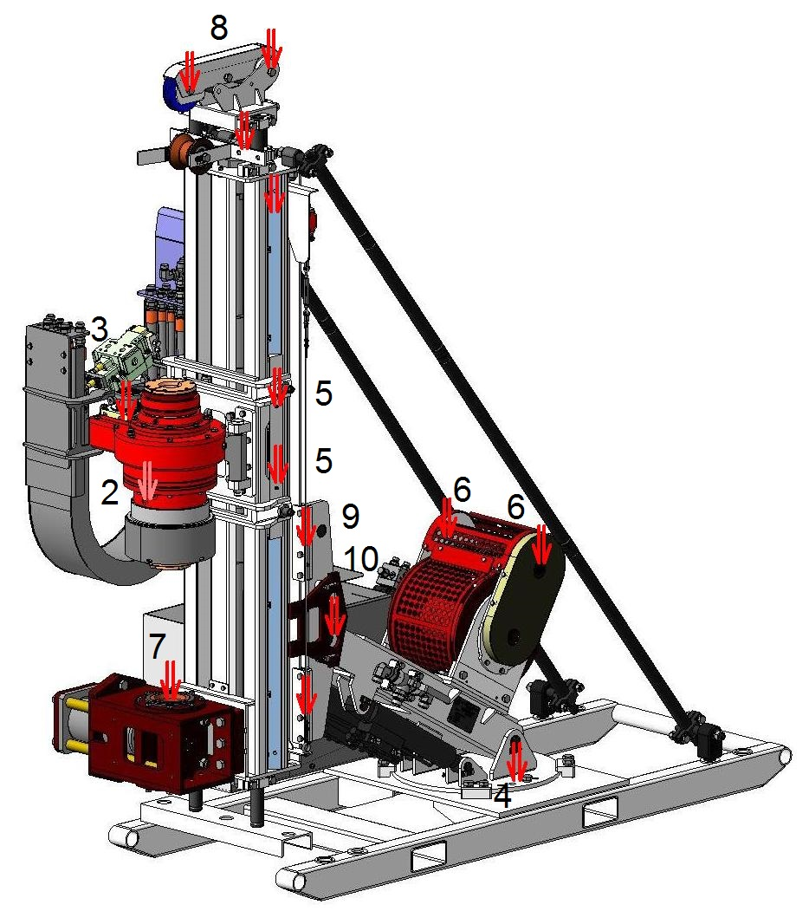

Figure 12 – Scheme of drilling block lubrication

Table 14 – Lubrication map

|  |  |  |  |  |  |  |  |
| --- | --- | --- | --- | --- | --- | --- | --- |
| № | Description | Location | | Number of lubrication points | Type of lubricant | Method of lubrication | Quantity |
| 1 | Hydraulic tank | Power Block | | 1 | Hydraulic oil Shell Tellus S2 V46 | Replace | 100 l |
| 2 | Cartridge | Rotator | | 5 | Lubricating grease Shell Gadus S2 V220AD | Grease gun | 2-3 shot |
| 3 | Rotator reducer | Rotator H/N | | 1 | Gear oil Shell Omala S2 G150 | Replace | 0,9/0,7 l |
| 4 | The rotary axis of the feed | | Feed unit | 2 | Lubricating grease Shell Gadus S2 V220AD | Grease gun | 2-3 shot |
| 5 | Upper carriage shoes | | upper carriage | 4 | Lubricating grease Shell Gadus S2 V220AD | Grease gun | 2-3 shot |
| 6 | Wireline Cable Stacker | | Wireline winch | 2 | Lubricating grease Shell Gadus S2 V220AD | Grease gun | 2-3 shot |
| 7 | Tubing catcher | | Feed | 1 | Lubricating grease Shell Gadus S2 V220AD | Grease gun | 2-3 shot |
| 8 | Rollers | | Cronblock | 2 | Lubricating grease Shell Gadus S2 V220AD | Grease gun | 2-3 shot |
| 9 | The rails of the lower carriage | | The lower carriage | 4 | Lubricating grease Shell Gadus S2 V220AD | Grease gun | 2-3 shot |
| 10 | Axis of rotation of the lower carriage | | The lower carriage | 1 | Lubricating grease Shell Gadus S2 V220AD | Grease gun | 2-3 shot |
| 11 | Mud pump AL 0918/AW1122 | | Drilling mud supply system | 1 | Gear oil Shell Omala S2 G150 | Replace | 3,8 l/4,2 l |

# Operation of the hydraulic system

## Operating principles of the hydraulic system

The system consists of two separate hydraulic circuits. Two pumps (main and auxiliary) mounted in tandem are driven by the flywheel of the power unit. The tandem of pumps is connected to the flywheel of the power unit through a transitional elastic coupling. Pumps – axial piston for operation in open circuits.

The main pump provides the flow rate for the rotation of the hydraulic motor of the rotator, the rapid movement of the rotator, the main winch and the Wireline winch.

The auxiliary pump provides flow for opening/closing of the tubing holder, cartridge rotator, the rotation of the hydraulic motor of the oil cooler, hydraulic unit the logical operations of the hydraulic pilot valve, the mud pump in the "drilling", and the working movement of the main cylinder.

## Main components of the hydraulic system

The principal hydraulic scheme – figures 13-17 – shows the main components of the hydraulic system.

**Main hydraulic pump (Figure 13 НА1)**

Type axial piston with measurement of load

Pressure 315 bar

Performance at 1500 rpm 124 l/min

**Auxiliary hydraulic pump (Figure13НА2)**

Type axial piston 28 cm3

with maximum pressure regulator

Pressure 260 bar

Performance at 1500 rpm 51 l/min

Oil cooler (Figure 12 МО)

Type air with hydraulic motor 11 cm3

Drive hydraulic

Maximum flow 400 l/min

Maximum pressure 26 bar

Hydraulic tank (Figure 13 MB)

It holds 100 liters of hydraulic oil, equipped with a sight glass and a thermometer, as well as an air filter. There is a drain tap (Figure 14 ВН4), ensuring controlled drainage of the oil. To fill the system, a manual pump, which pumps the oil through the drain filter, is used.

Filters.

The structure of the hydraulic system includes a drain filter replacement (figure 14 F4), which is located on the top cover of the hydraulic tank. The design of the hydraulic tank includes three coarse filters (Figure 14 F1, F2, F3), located on the feed line of each pump. Air filter-breather (Figure 15 F5) is located on the top cover of the hydraulic tank. The level (Figure 14 Y) of the hydraulic oil tank is located on the side surface.

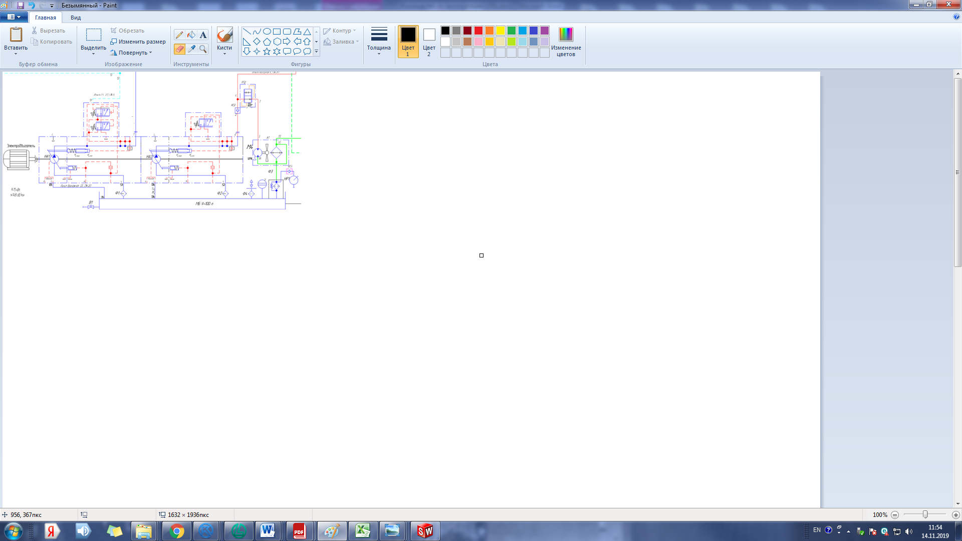

Figure 13 –Hydraulic block of flow distribution. Hydraulic circuit fragment.

Explanation of Figure 13:

КО2-Reverse hydraulic valve

РП2-Hydraulic block

ВН1-Reducing valve

Ф1-Filter suction

Ф2-Filter suction

Ф3-Filter drain

Ф4-Air filter-breather

Ф5-Fine filter

НА1- Main pump

НА2-Auxiliary pump

М3-Hydraulic motor drive oil cooler.

НР1-Manual pump

У - Level indicator

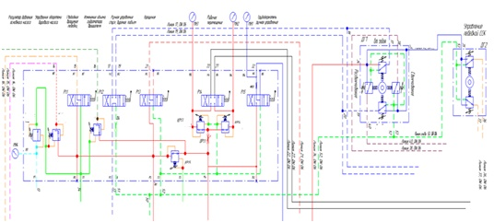

Figure 14- А1 - Hydraulic block of pilot valves (a fragment of the scheme)

Explanation of Figure 14:

МН4 - Gauge

КП 1.1 - Hydraulic valve

КР 1.1-Hydraulic valve

Р1.1-Three-positioncontrolvalve

КР1.2- Three-position control valve

Р1.2 – Three-position control valve

Р1.3- Three-position control valve

КР1.3- Three-position control valve

КР 1.5- Three-position control valve

Р1.4- Three-position control valve

ДР1.1-Hydraulic throttle

РП1-Hydraulic valve

К01-Check valve

МН1-Gauge

МН2-Gauge

ДГ1-HydraulicJoystick

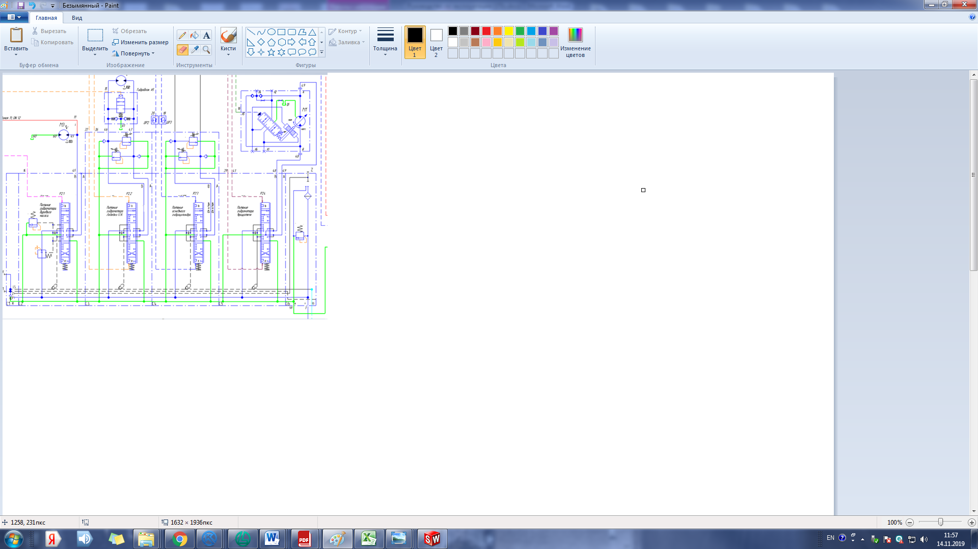

Figure 15- А2 Hydraulic block of proportional distributors (a fragment of the scheme)

Explanation of Figure 15:

Р2.1- Three-position control valve

Р2.2- Three-position control valve

Р2.3- Three-position control valve

Р2.4- Three-position control valve

М3-Hydraulic motor

М2-Hydraulic motor

ДР2-Hydraulic throttle

ДР3- Hydraulic throttle

М1-Hydraulic motor

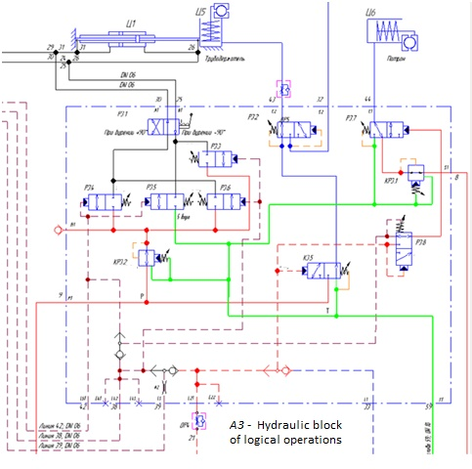

Figure16- А3 Hydraulic block of logical operations (a fragment of the scheme)

Explanation of Figure 16:

ДР4-Hydraulic throttle

К3.5-Hydraulicvalve

КР3.2-Hydraulic valve

Р3.8- Two-position control valve

Р3.4- Two-position control valve

Р3.5- Two-position control valve

Р3.6- Two-position control valve

КР3.1- Hydraulic valve

Р3.3- Two-position control valve

Р3.1- Two-position control valve

Р3.2- Two-position control valve

Р3.7- Two-position control valve

Ц1-Hydraulic ram

Ц5-Hydraulic ram

Ц6-Hydraulic ram

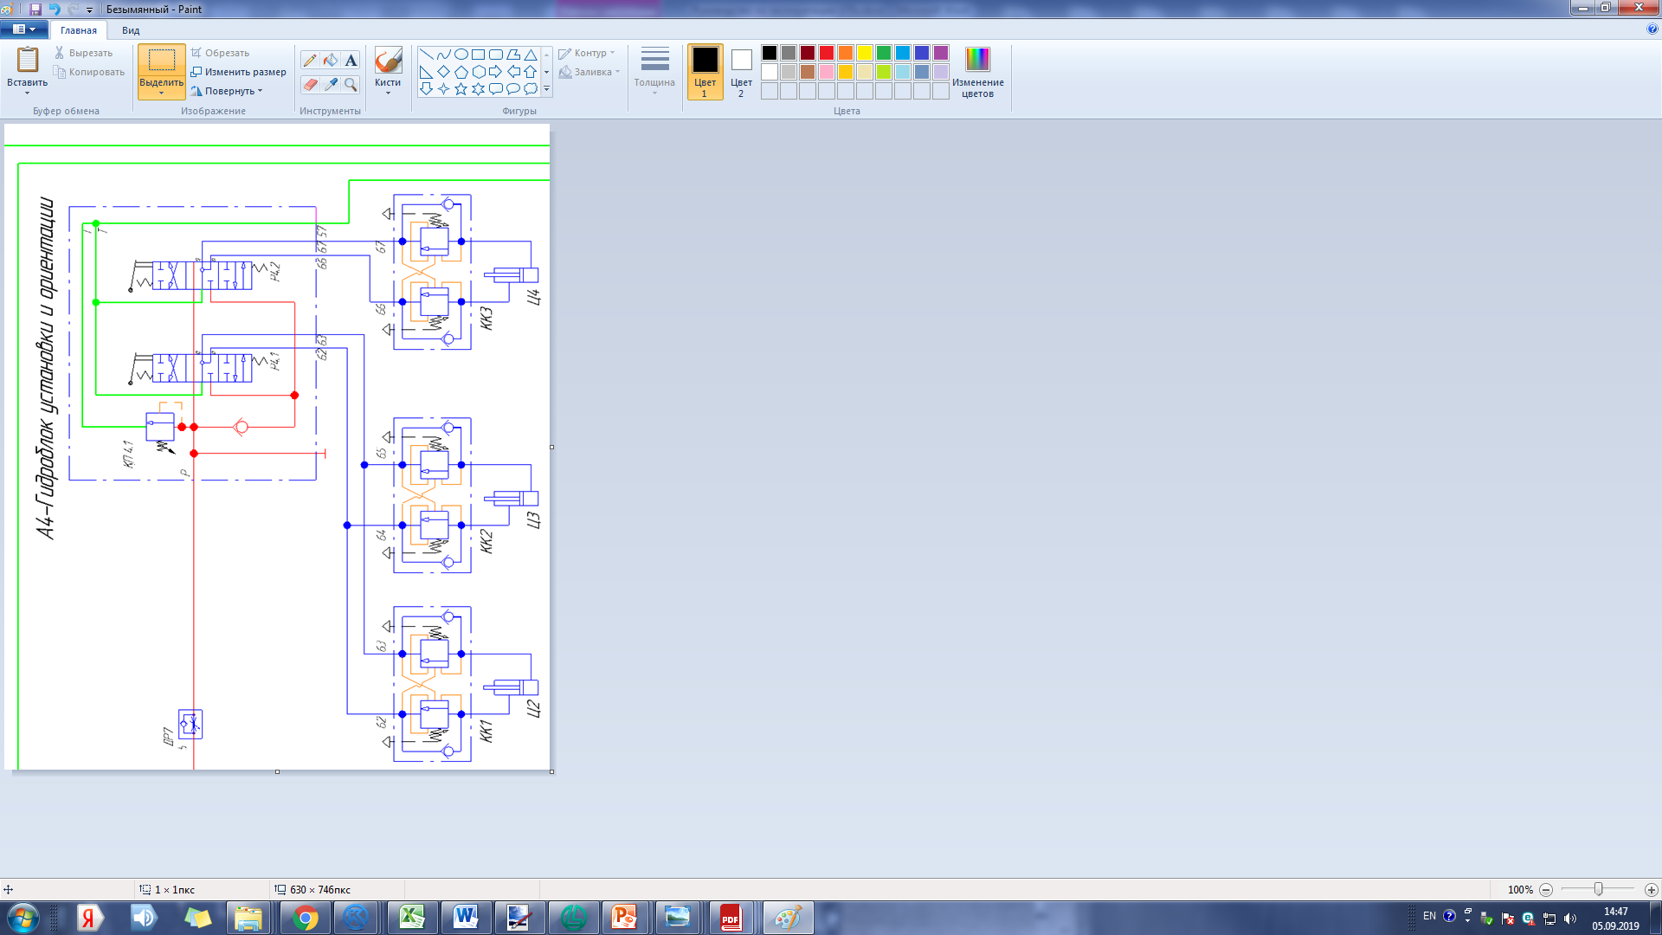

Figure 17- А4 hydraulic block of installation and orientation (a fragment of the scheme)

Explanation of Figure 17:

КК1- Hydraulic block

КК2- Hydraulic block

КК3- Hydraulic block

Ц2- Hydraulic ram

Ц3- Hydraulic ram

Ц4- Hydraulic ram

ДР7- Hydraulic throttle

Д1- Three-way high pressure diverter

Ф5- Fine filter

КП4.1- Three-position control valve

Р4.1- Three-position control valve

Р4.2- Three-position control valve

# 

# Storage

To ensure the operability of the rig, saving material and money for its repair and preparation for work, it is necessary to strictly observe the rules of storage outside working hours.

The equipment can be subjected to short-term storage (from 10 days to 2 months) or long-term storage (more than 2 months). The equipment must be stored indoors or under a canopy. The appointed term of storage of the equipment 1 year, under a canopy – 9 months according to GOST 15150.

During storage once a month it is necessary to check the equipment and eliminate the detected discrepancies.

## Preparing for short-term storage

- lower the frame of the drilling rig on the wooden platforms;

- disconnect the terminals of the batteries;

- shut off valves of hydraulic pump supply lines;

- perform maintenance 1;

- cover with lithol-24 unpainted surfaces and

the protruding rods of hydraulic cylinders;

- perform preparing of rig skids for short-term storage according to an operating manual for this unit.

## Preparing for long-term storage

- prepare the equipment for short-term storage;

- perform maintenance 2;

- prepare the units for long-term storage according to the operating instructions for this unit.

# Transportation

When moving the unit must be moved to the transport position. All elements of the rig must be securely fastened to the frame of the rig or the mast of the rig.

Transportation can be carried out by road or rail.

It is FORBIDDEN to transport the rig in the operating position.

Placement and fastening of the rig on the platform, as well as in gondola cars must meet the requirements of "Technical conditions for placement and fastening of goods in wagons and containers" (approved. THE MINISTRY OF RAILWAYS OF THE RUSSIAN FEDERATION OF 27.05.2003 N TSM-943).

Loading, placement, fastening, shelter, and unloading during transportation by road must comply with the "Rules of carriage of goods," publishing house "Transport," Moscow, 1977.

When transporting, the outer openings must be closed with plugs.

During transportation, it is necessary to provide protection in terms of the impact of climatic factors – 5 according to GOST 15150-69, and in terms of mechanical – medium (C) according to GOST 23170-78.

The scheme of slinging is given in Figure 18, 19, 20.

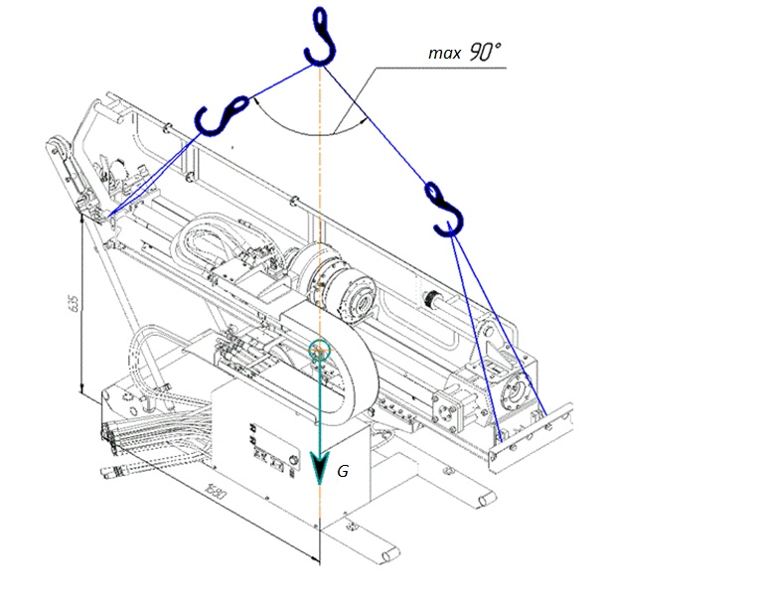

Figure-18 – The scheme of slinging for Drilling Block (Feed Stroke 1800 mm)

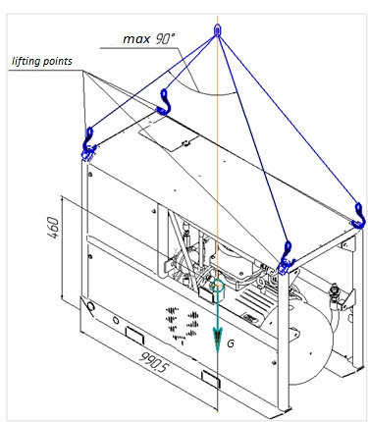

Figure-19- The scheme of slinging for Power Block

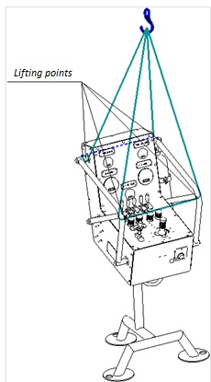

Figure-20- The scheme of slinging for Control Block

Also delivery on mine development is possible by means of wheel chassis see figures 21, 22, (optional).

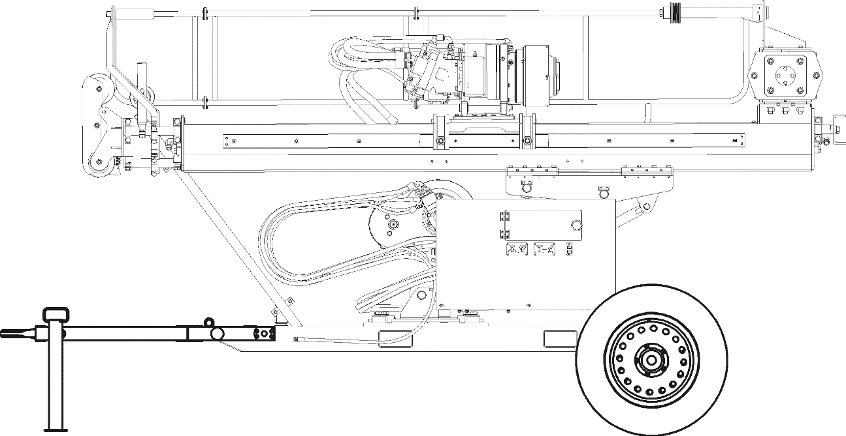

Figure-21-Drilling Block on the chassis.

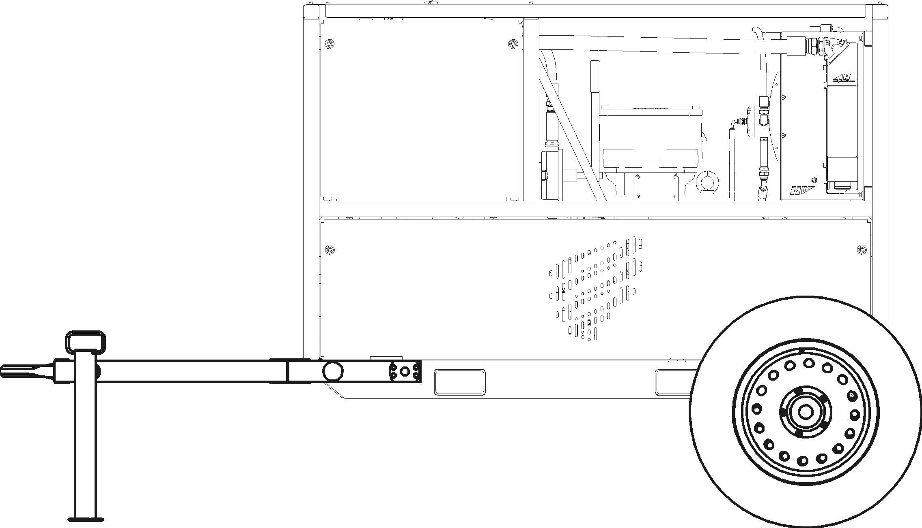

Figure-22-Power Block on the chassis.

# Utilization

Before proceeding with the disposal of equipment, you should pay special attention to safety issues. The danger of disposal is the residual energy of the compressed liquid, in mechanisms with hydraulic elements, etc. The key safety factors are the use of personal protective equipment and compliance with occupational safety.

In the case of disposal of the drilling rig at the end of the designated service life, it is necessary to perform in accordance with the national standard GOST R 53692-2009.

All stages of the technological cycle for recycling must be carried out in accordance with the current natural legislation of the Russian Federation and must be documented in the prescribed manner. The disposal procedure is determined by the organization operating the drilling rig.

At the stage of utilization of the rig, the maximum return of material resources from the installation as secondary raw materials (ferrous metals, non-ferrous metals, precious metals, rubber, plastic, etc.) should be ensured. When sending for disposal, the unit must be cleaned and washed, the pipelines and the hydraulic fluid tank washed from the working environment and steamed.

Improper disposal of waste can pose a threat to the environment. Potentially harmful liquids should be disposed of in accordance with local regulations.

Draining the liquid must be made in a sealed container. It is not allowed to spill waste on the ground, in the sewers, or in any water source.

# Appendix A

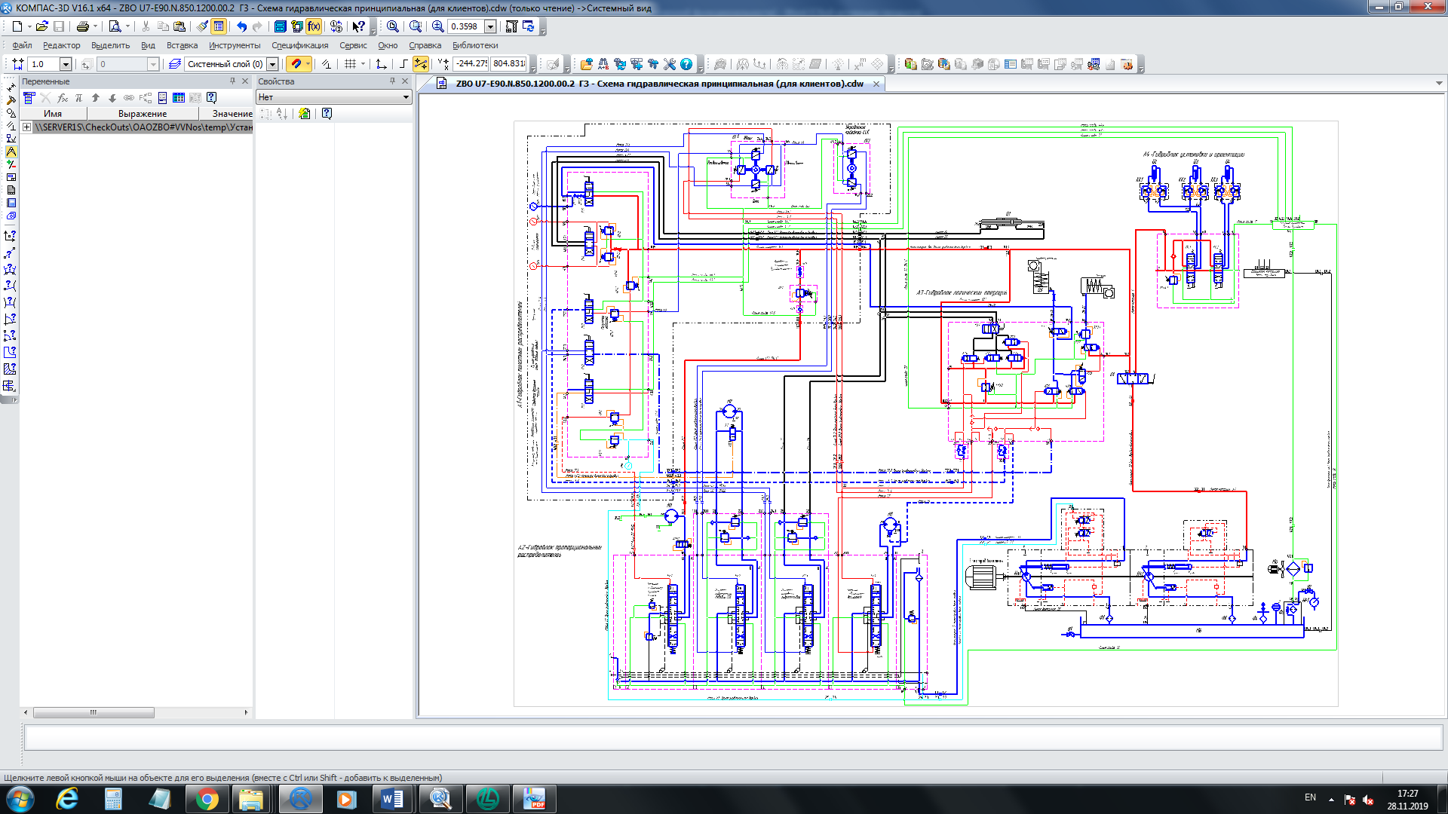

Hydraulic circuit diagram

# Appendix B

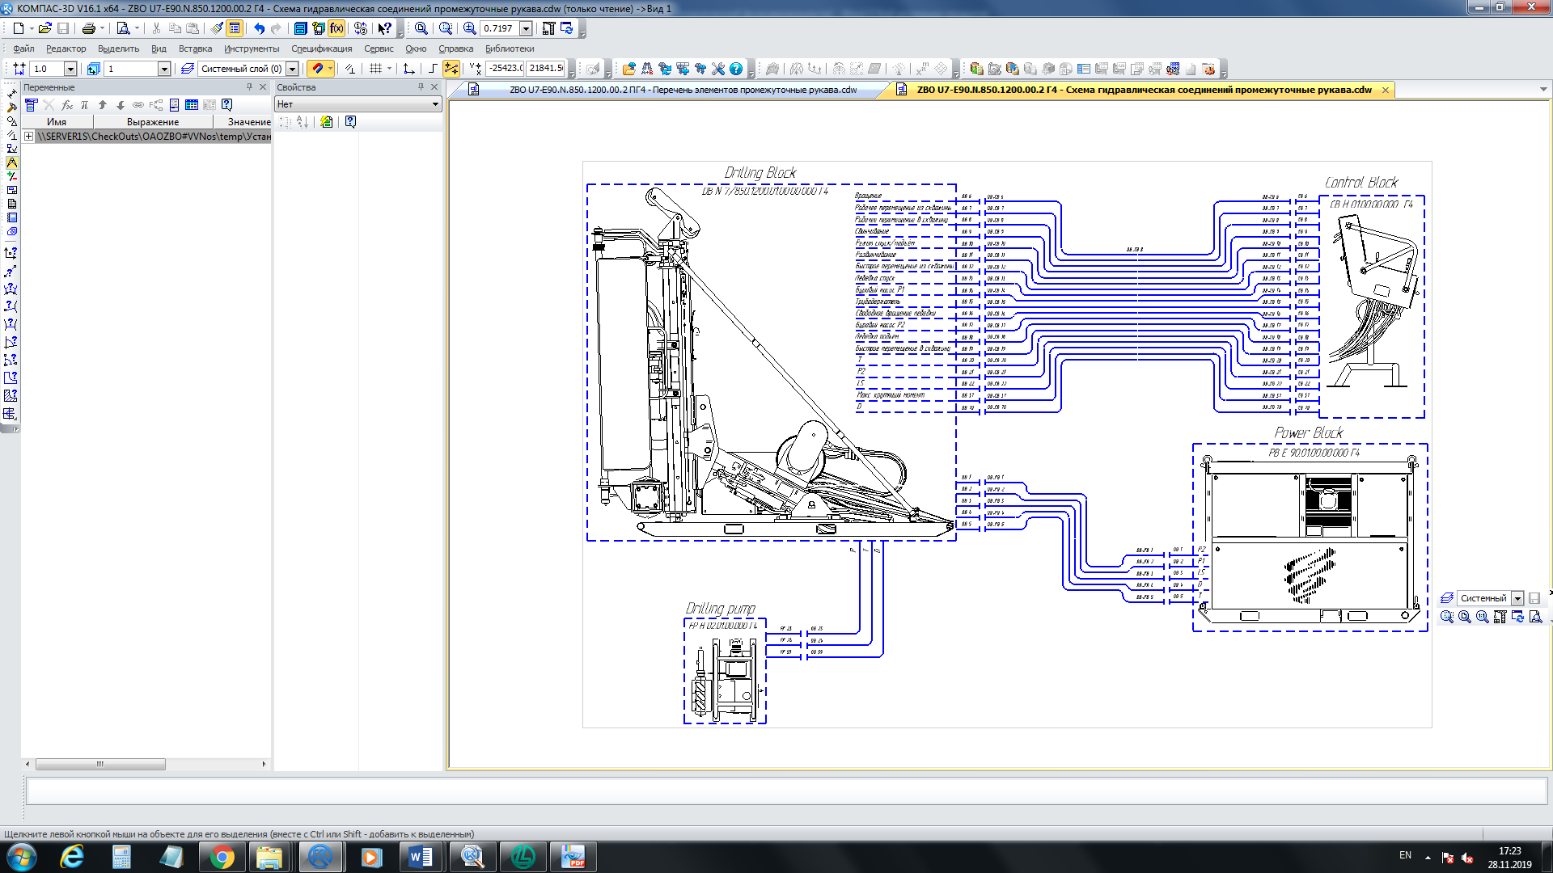

Scheme of hydraulic connections

List of elements

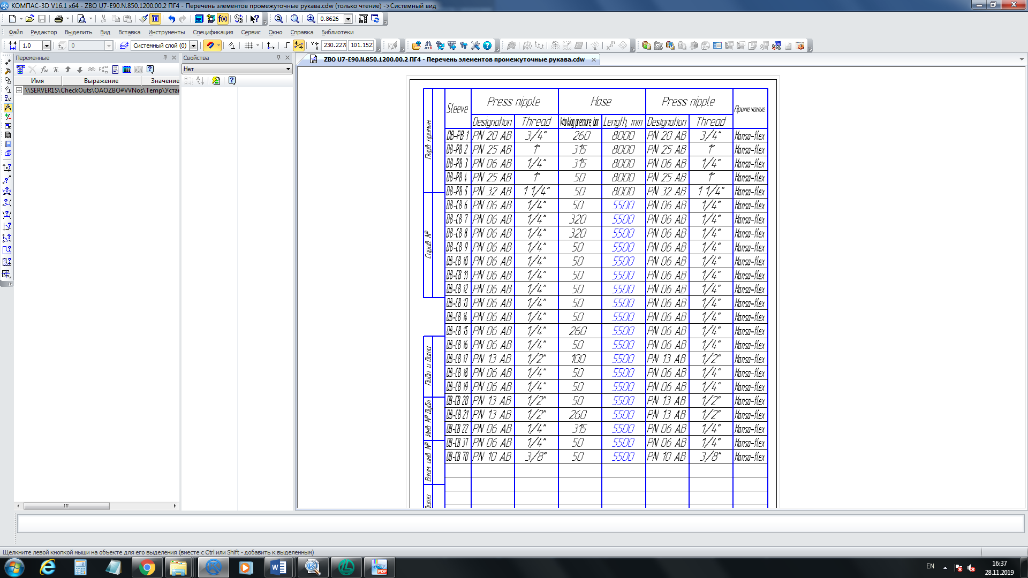

# FOR NOTES

__________________________________________________________________

______________________________________________________________________________________________________________________________________________________________________________________________________________________________________________________________________________________________________________________________________________________________________________________________________________________________________________________________________________________________________________________________________________________________________________________________________________________________________________________________________________________________________________________________________________________________________________________________________________________________________________________________________________________________________________________________________________________________________________________________________________________________________________________________________________________________________________________________________________________________________________________________________________________________________________________________________________________________________

__________________________________________________________________

_________________________________________________________________

__________________________________________________________________

__________________________________________________________________

__________________________________________________________________

__________________________________________________________________

__________________________________________________________________

__________________________________________________________________

______________________________________________________________________________________________________________________________________________________________________________________________________________________________________________________________________________________________________________________________________________________________________________________________________________________________________________________________________________________________________________________________________________________________________________________________________________________________________________________________________________________________________________________________________________________________________________________________________________________________________________________________________________________________________________________________________________________________________________________________________________________________________________________________________________________________________________________________________________________________________________________________________________________________________________________________________________________________________

__________________________________________________________________

_________________________________________________________________

__________________________________________________________________

__________________________________________________________________

__________________________________________________________________

__________________________________________________________________

__________________________________________________________________

**Record of revisions**

|  |  |  |  |  |  |  |  |  |  |
| --- | --- | --- | --- | --- | --- | --- | --- | --- | --- |
| Changes | Sheet (page) numbers | | | | Total sheets (pages) in the document | No. of document | Incoming no. and date of the accompanying document | Signature | Date  new |
| changed | replaced | new | cancellations |
|
|  |  |  |  |  |  |  |  |  |  |
|  |  |  |  |  |  |  |  |  |  |
|  |  |  |  |  |  |  |  |  |  |
|  |  |  |  |  |  |  |  |  |  |
|  |  |  |  |  |  |  |  |  |  |
|  |  |  |  |  |  |  |  |  |  |
|  |  |  |  |  |  |  |  |  |  |
|  |  |  |  |  |  |  |  |  |  |
|  |  |  |  |  |  |  |  |  |  |
|  |  |  |  |  |  |  |  |  |  |
|  |  |  |  |  |  |  |  |  |  |
|  |  |  |  |  |  |  |  |  |  |
|  |  |  |  |  |  |  |  |  |  |
|  |  |  |  |  |  |  |  |  |  |
|  |  |  |  |  |  |  |  |  |  |
|  |  |  |  |  |  |  |  |  |  |
|  |  |  |  |  |  |  |  |  |  |
|  |  |  |  |  |  |  |  |  |  |
|  |  |  |  |  |  |  |  |  |  |
|  |  |  |  |  |  |  |  |  |  |
|  |  |  |  |  |  |  |  |  |  |
|  |  |  |  |  |  |  |  |  |  |
|  |  |  |  |  |  |  |  |  |  |
|  |  |  |  |  |  |  |  |  |  |
|  |  |  |  |  |  |  |  |  |  |
|  |  |  |  |  |  |  |  |  |  |